TABLES used in mysql

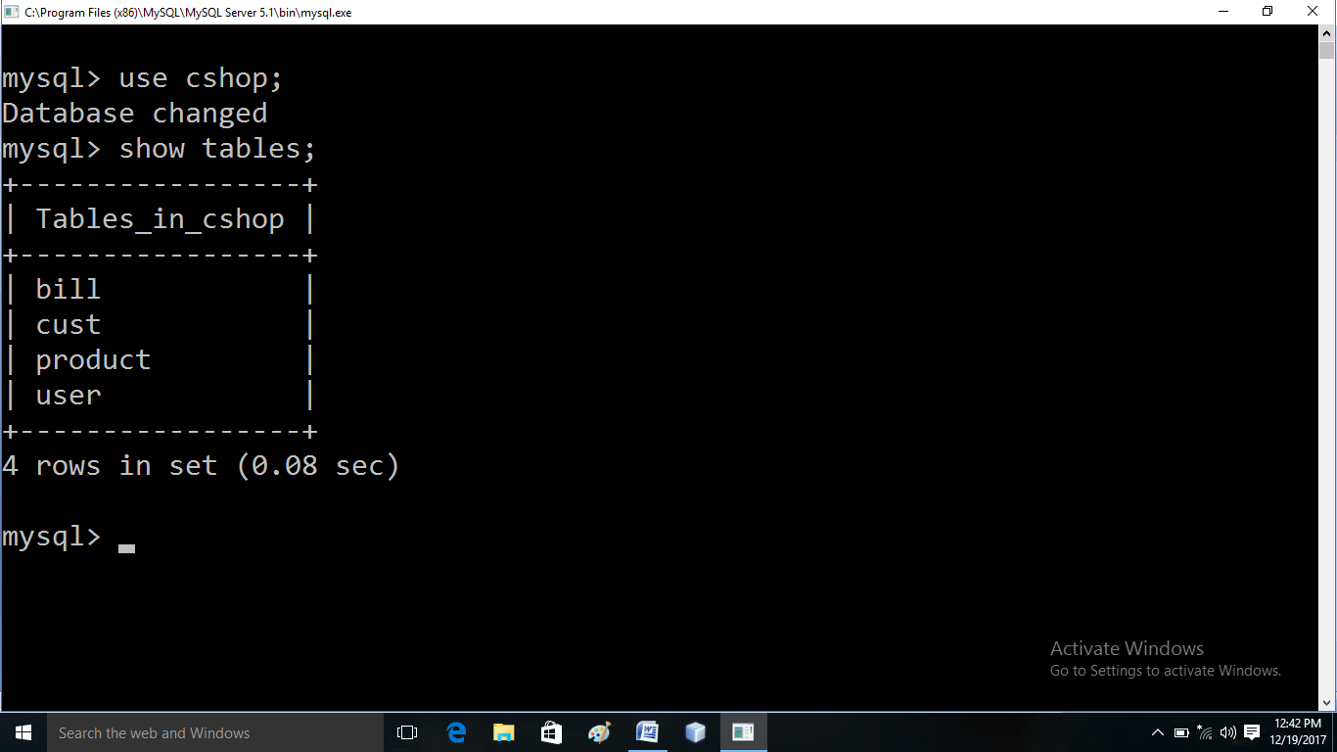

user table

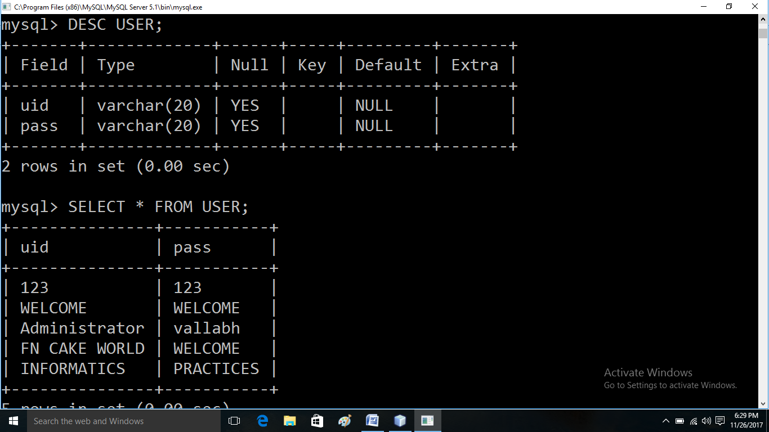

CUSTOMER TABLE

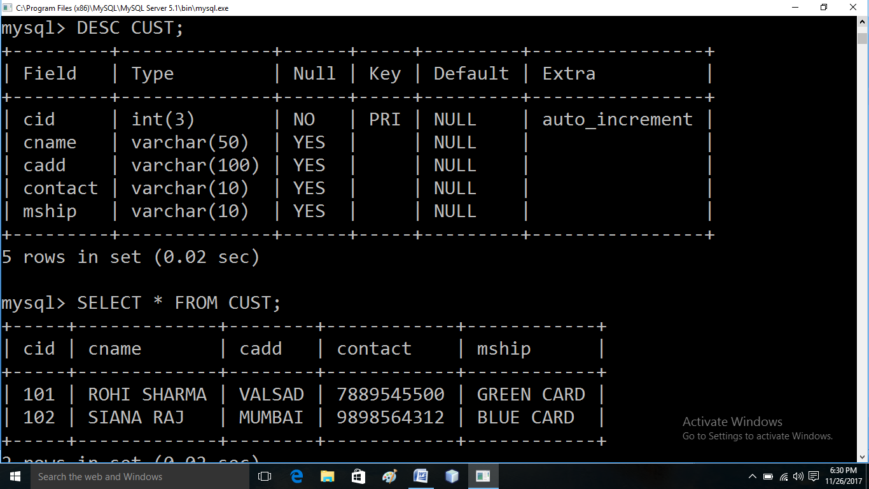

PRODUCT TABLE

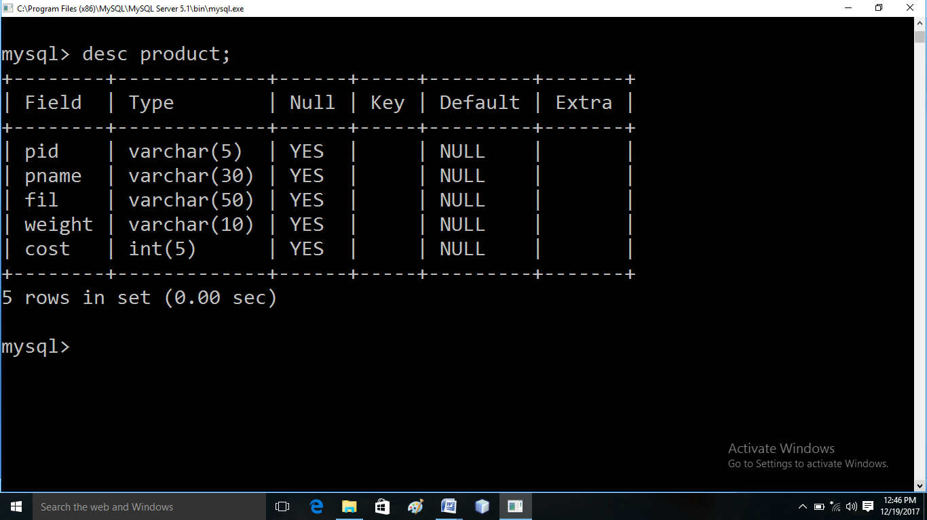

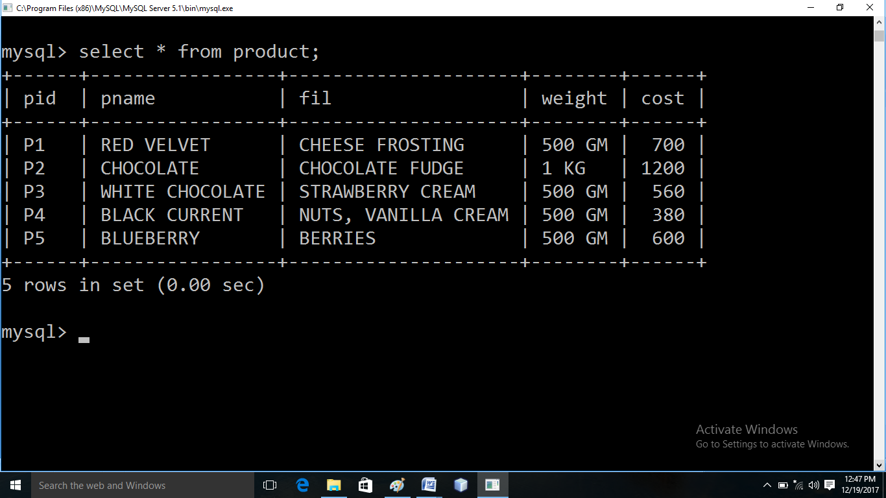

BILL TABLE

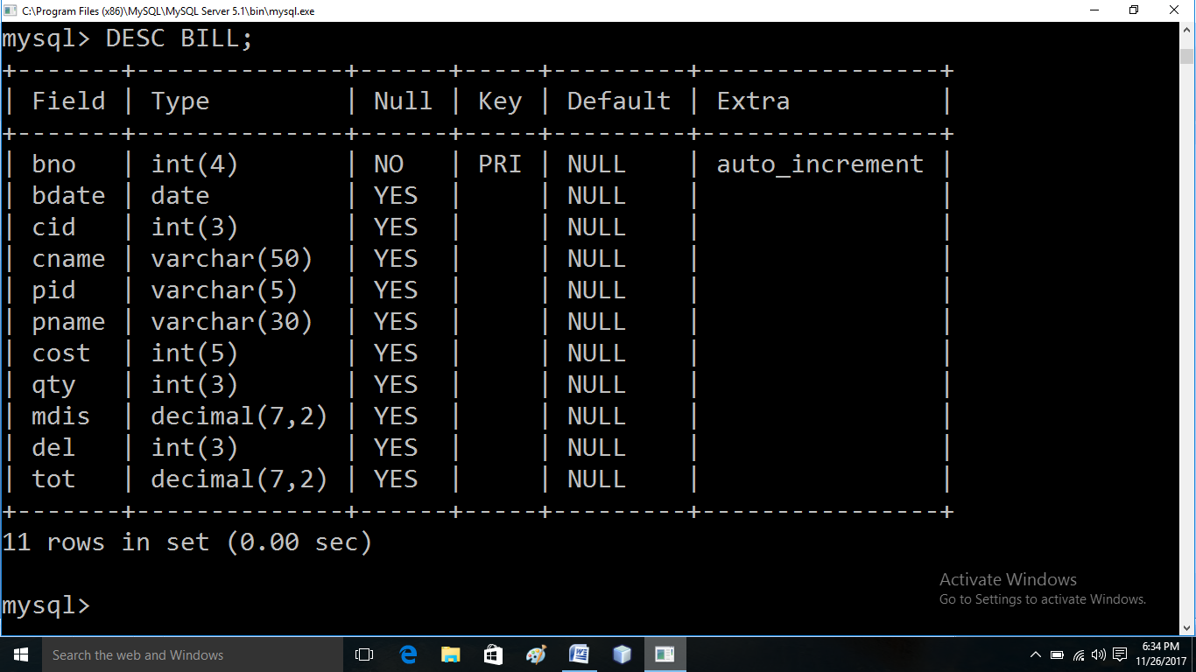

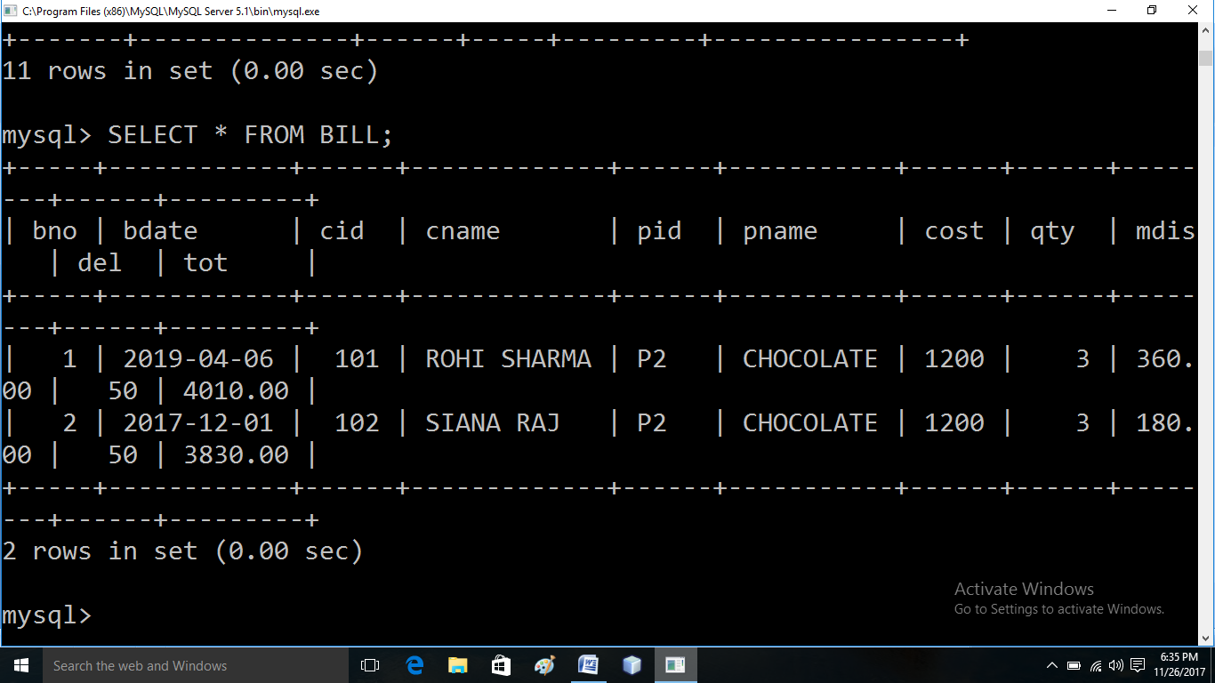

LOGIN FORM

LOGIN BUTTON

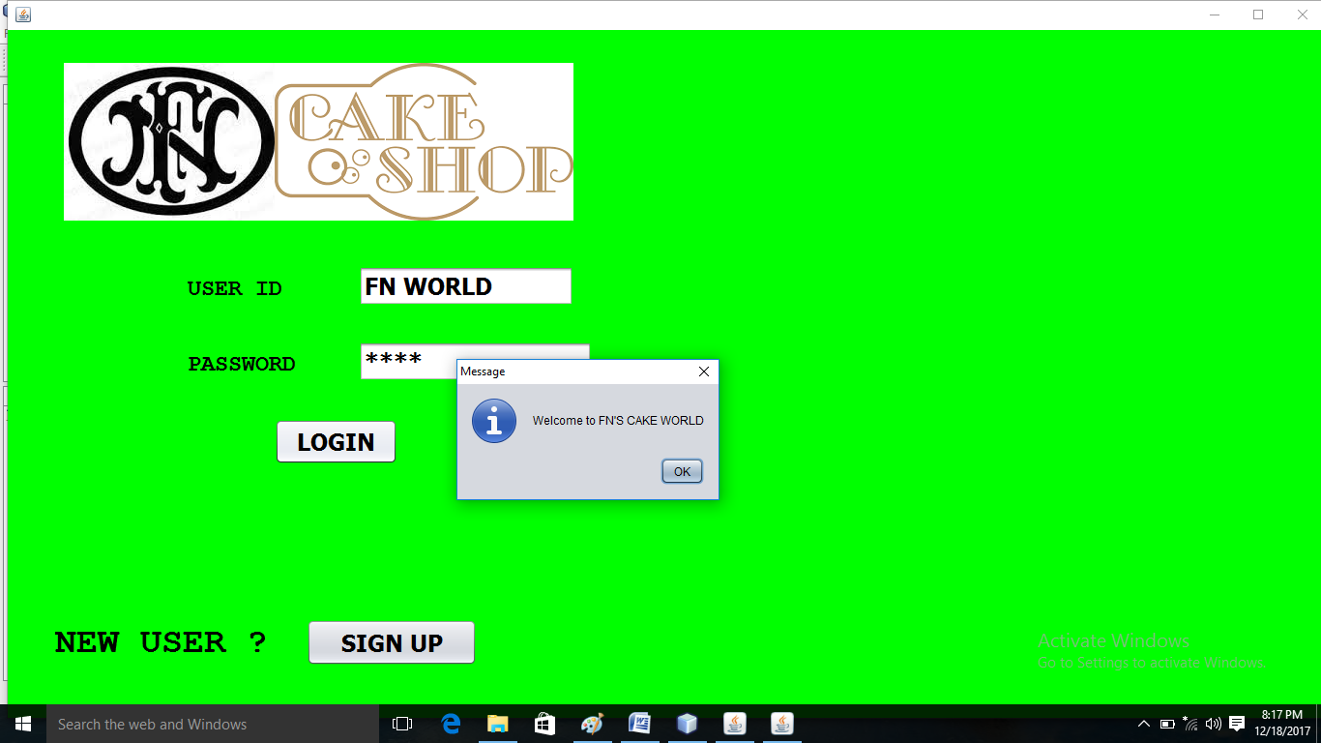

private void jButton1ActionPerformed(java.awt.event.ActionEvent evt) {

String u=u1.getText(),p=p1.getText();

try{Class.forName("java.sql.Driver");

Connection cn=DriverManager.getConnection("jdbc:mysql://localhost:3306/cshop","root","");

Statement st=cn.createStatement();

ResultSet r=st.executeQuery("select * from user;");

while(r.next()){

if(u.equals(r.getString(1))&& p.equals(r.getString(2))){

JOptionPane.showMessageDialog(null, "WELCOME TO FN’S CAKE WORLD");

main l=new main();

this.dispose();

l.setVisible(true);

}

}

SIGNUP BUTTON

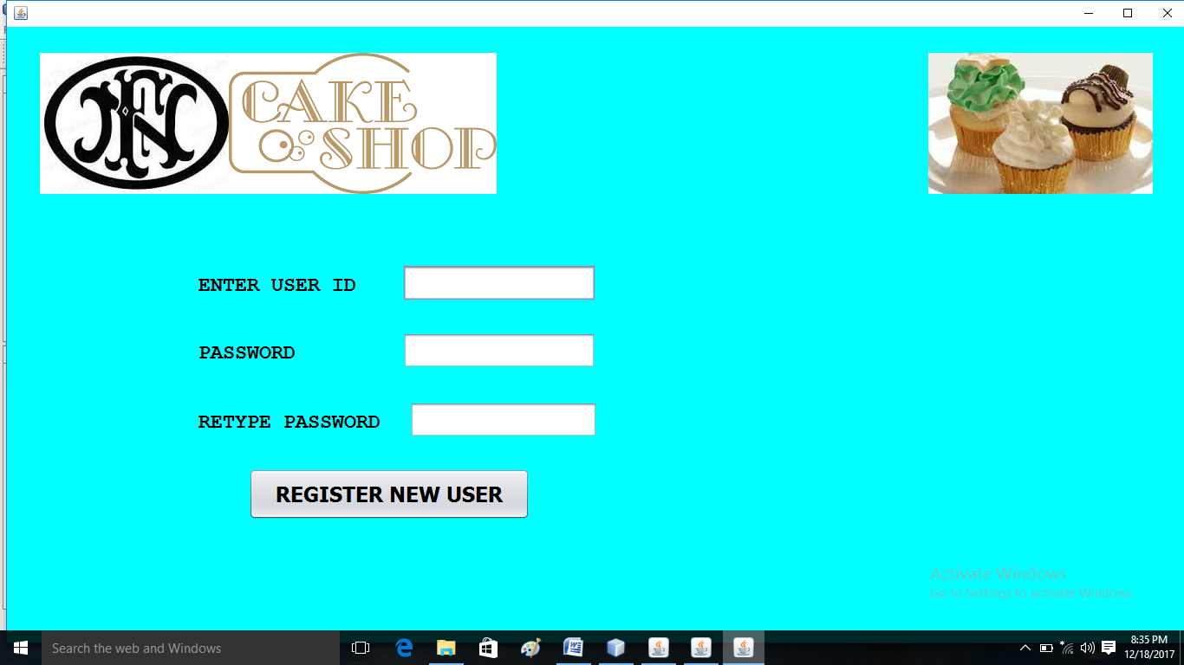

**private void jButton2ActionPerformed(java.awt.event.ActionEvent evt) {**

**signup S=new signup();**

**this.dispose();**

**S.setSize(1400, 700);**

**S.setVisible(true);**

}

REGISTER NEW USER BUTTON

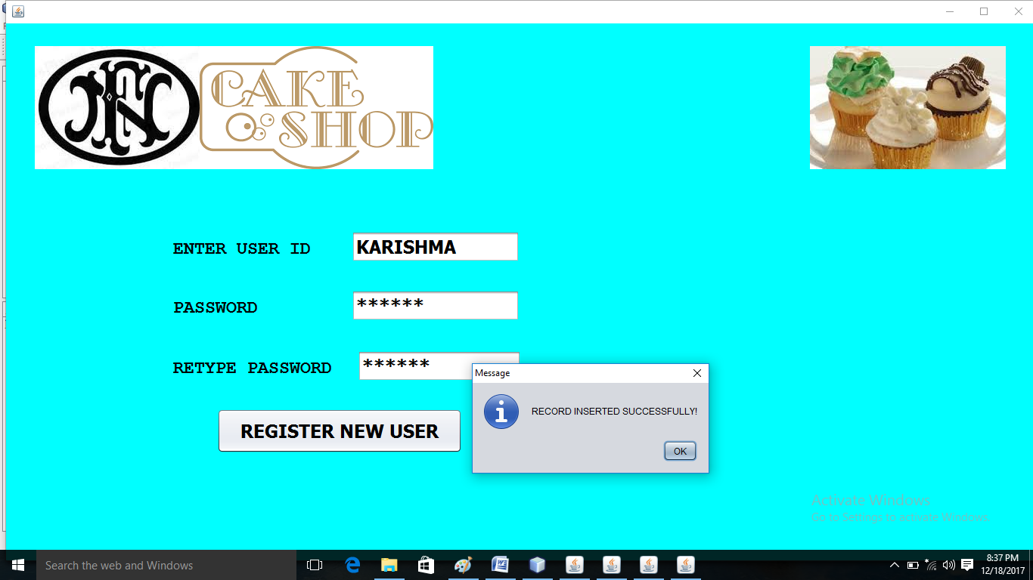

private void jButton2ActionPerformed(java.awt.event.ActionEvent evt) {

String p1=P1.getText(),p2=P2.getText();

if(p1.equals(p1))

{

try{Class.forName("java.sql.Driver");

Connection cn=DriverManager.getConnection("jdbc:mysql://localhost:3306/cshop","root","");

Statement st=cn.createStatement();

st.executeUpdate("insert into user values('"+T1.getText().trim()+"','"+p1+"');");

JOptionPane.showMessageDialog(null, "RECORD INSERTED SUCCESSFULLY!");

login l=new login();

this.dispose();

l.setVisible(true);

}

catch(Exception e){System.out.println("error"+e);}

}

else{

JOptionPane.showMessageDialog(null, "PLEASE RE-ENTER YOUR PASSWORD!");

}

}

MAIN FORM

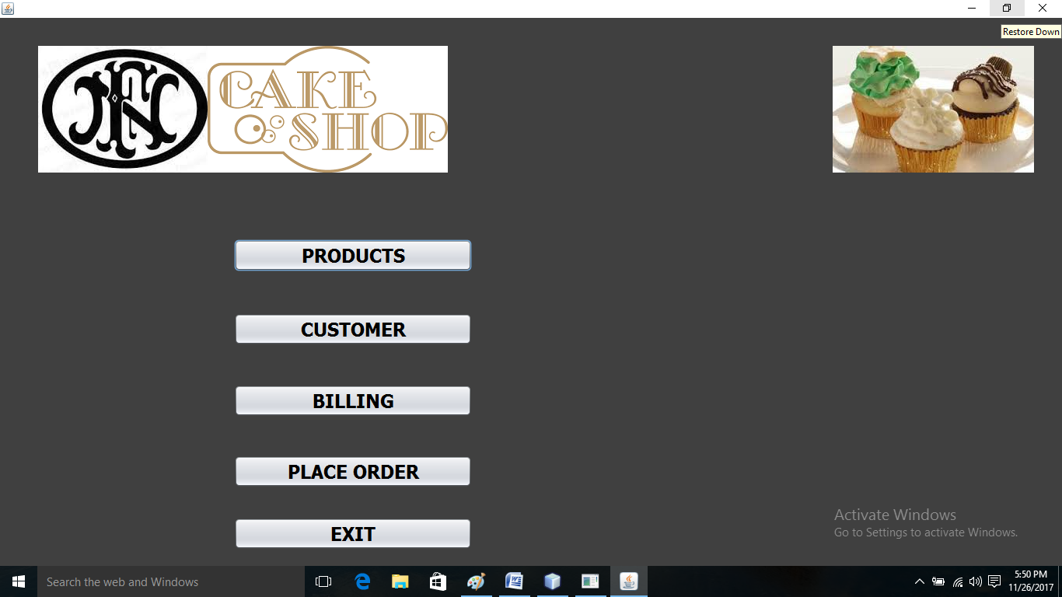

private void formWindowActivated(java.awt.event.WindowEvent evt) {

this.setSize(1450, 750);

}

PRODUCTS BUTTON

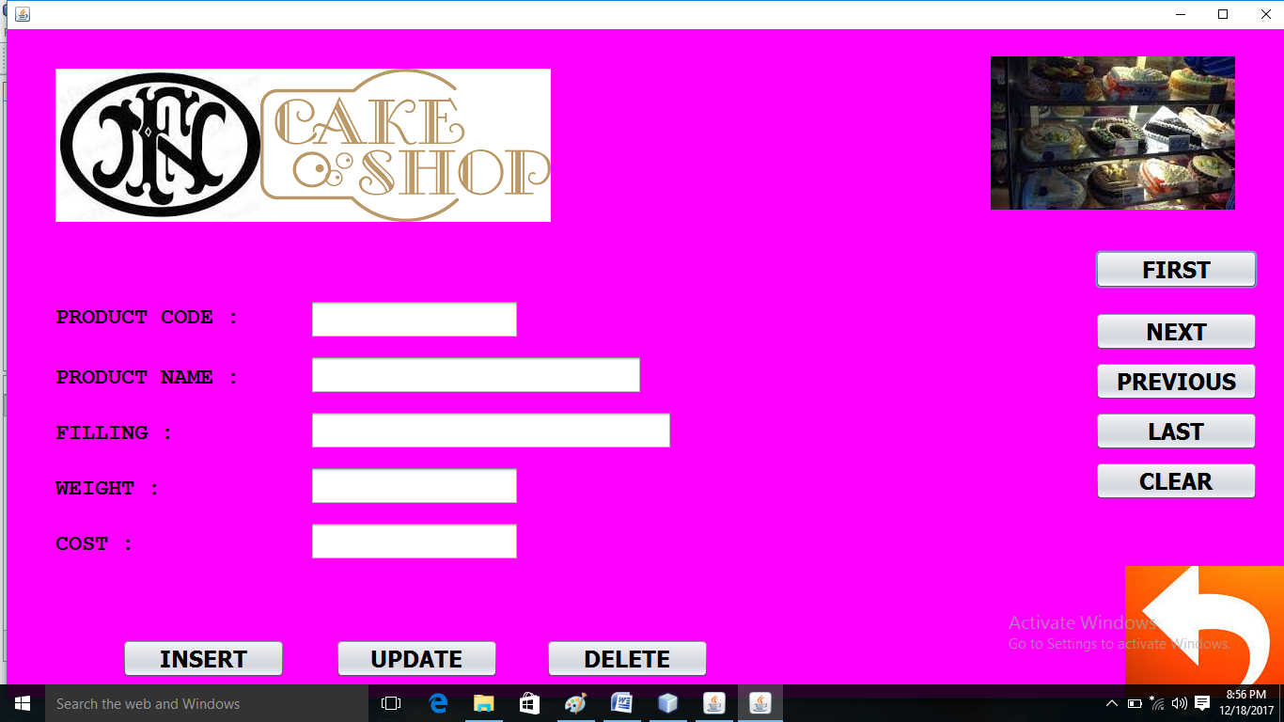

private void jButton2ActionPerformed(java.awt.event.ActionEvent evt) {

PRODUCT l=new PRODUCT();

this.dispose();

l.setVisible(true);

}

CUSTOMER BUTTON

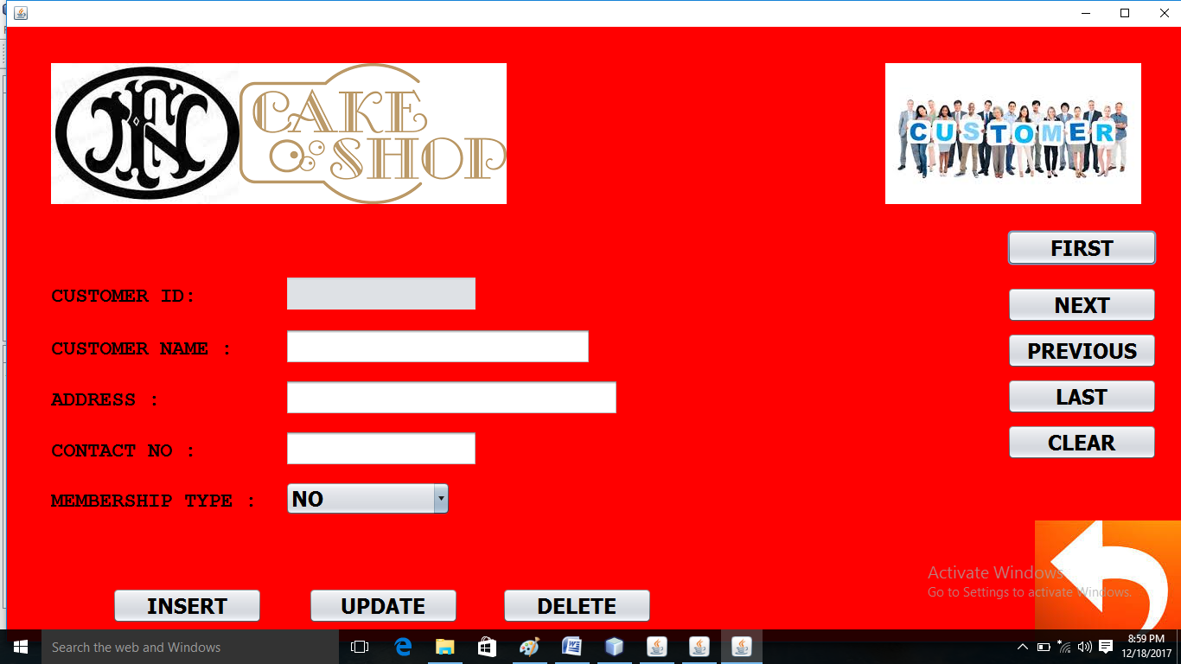

private void jButton3ActionPerformed(java.awt.event.ActionEvent evt) {

CUSTOMER l=new CUSTOMER();

this.dispose();

l.setVisible(true);

}

BILLING BUTTON

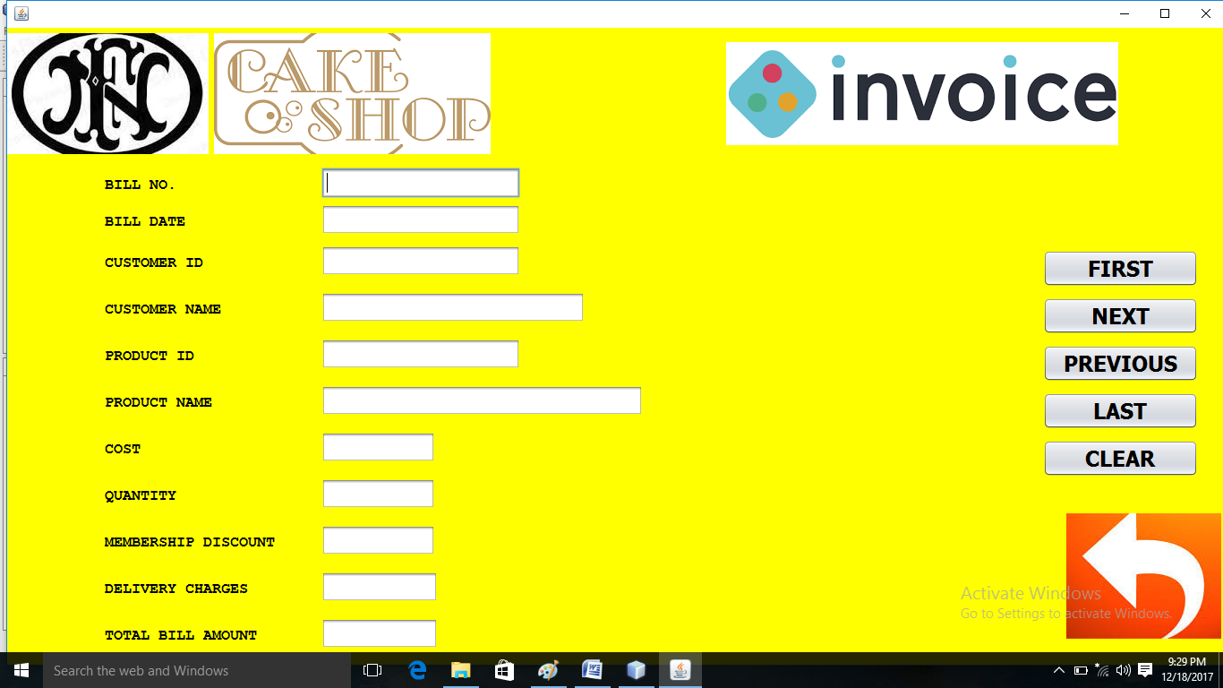

private void jButton4ActionPerformed(java.awt.event.ActionEvent evt) {

BILLING l=new BILLING();

this.dispose();

l.setVisible(true);

}

PLACE ORDER BUTTON

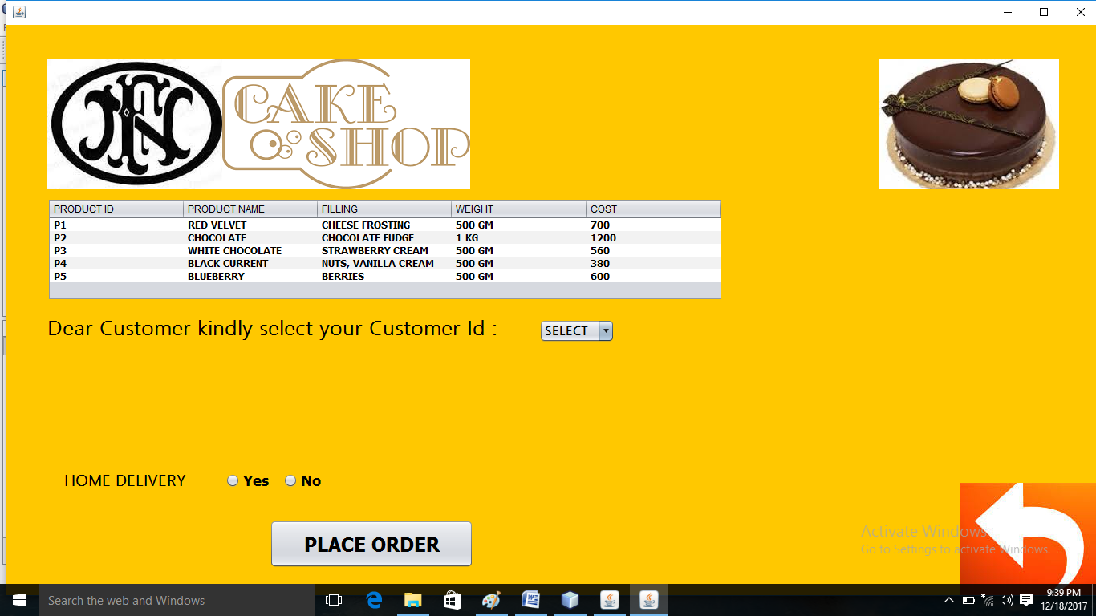

private void jButton5ActionPerformed(java.awt.event.ActionEvent evt) {

ORDER O=new ORDER();

this.dispose();

O.setVisible(true);

}

EXIT BUTTON

private void jButton6ActionPerformed(java.awt.event.ActionEvent evt) {

System.exit(0);

}

PRODUCT FORM (WINDOW ACTIVATED EVENT)

private void formWindowActivated(java.awt.event.WindowEvent evt) {

this.setSize(1500, 750);

try{

Class.forName("java.sql.Driver");

cn1=DriverManager.getConnection("jdbc:mysql://localhost:3306/cshop","root","");

st1=cn1.createStatement();

r1=st1.executeQuery("select * from product");

//JOptionPane.showMessageDialog(null, "RECORD INSERTED SUCCESSFULLY!");

}

catch(Exception e){System.out.println("error"+e);}

}

PRODUCT FORM (FIRST RECORD)

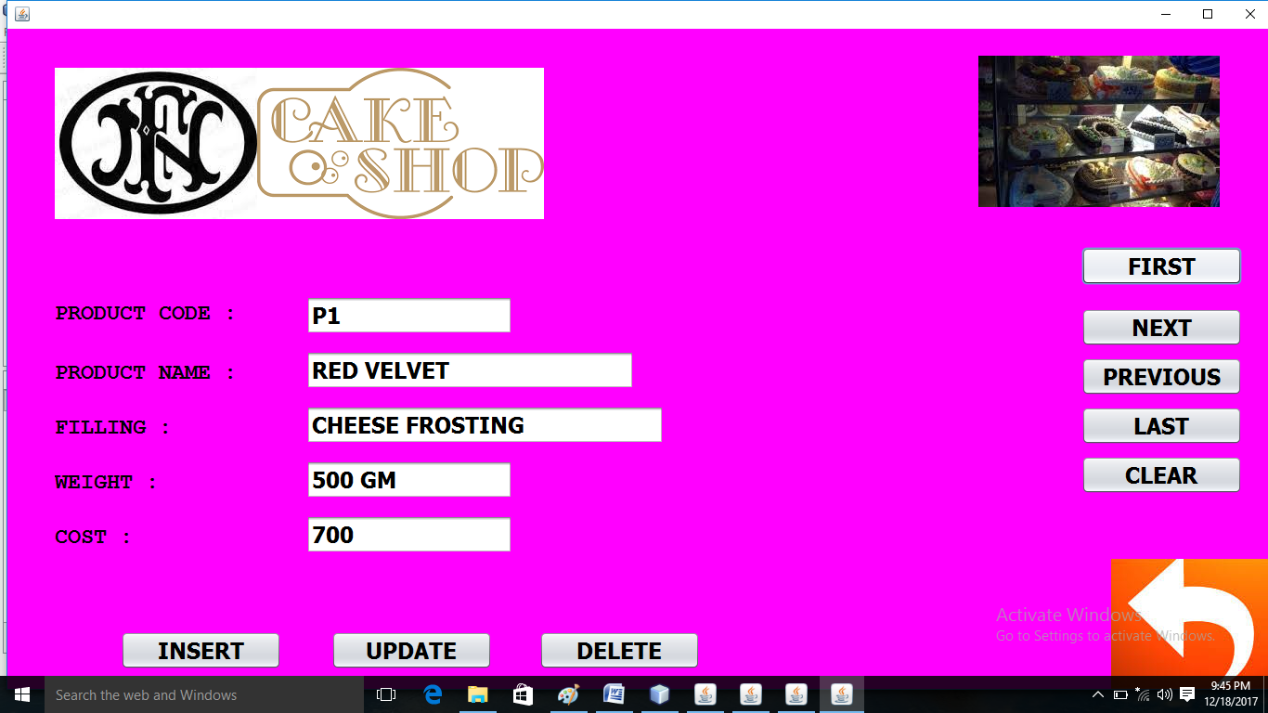

private void jButton9ActionPerformed(java.awt.event.ActionEvent evt) {

try{

r1.first();

t1.setText(r1.getString(1));t2.setText(r1.getString(2));t3.setText(r1.getString(3));t4.setText(r1.getString(4));t5.setText(r1.getString(5));

//JOptionPane.showMessageDialog(null, "RECORD INSERTED SUCCESSFULLY!");

}

catch(Exception e){System.out.println("error"+e);}

}

PRODUCT FORM (NEXT RECORD)

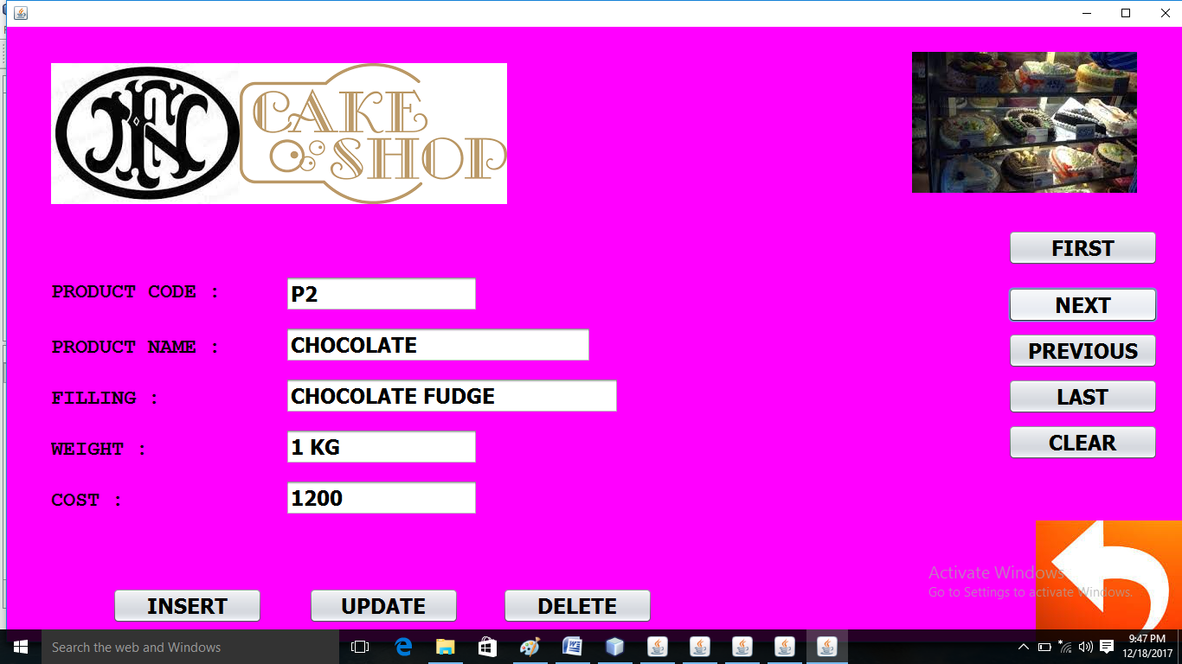

private void jButton7ActionPerformed(java.awt.event.ActionEvent evt) {

try{

r1.next();

t1.setText(r1.getString(1));t2.setText(r1.getString(2));t3.setText(r1.getString(3));t4.setText(r1.getString(4));t5.setText(r1.getString(5));

//JOptionPane.showMessageDialog(null, "RECORD INSERTED SUCCESSFULLY!");

}

catch(Exception e){System.out.println("error"+e);

}

PRODUCT FORM (LAST RECORD)

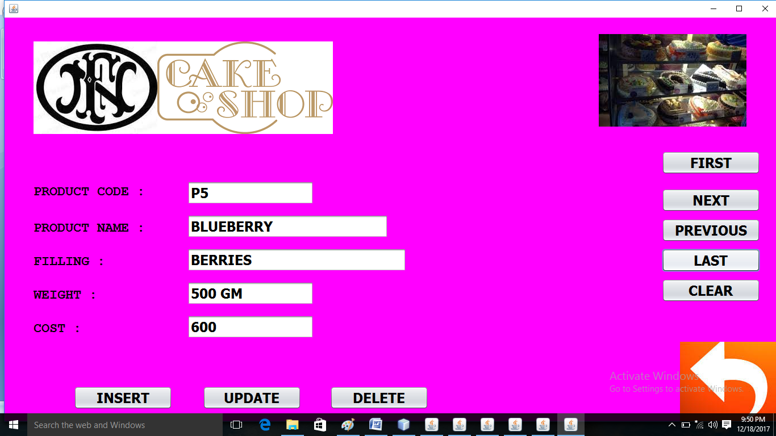

private void jButton10ActionPerformed(java.awt.event.ActionEvent evt) {

try{

r1.last();

t1.setText(r1.getString(1));t2.setText(r1.getString(2));t3.setText(r1.getString(3));t4.setText(r1.getString(4));t5.setText(r1.getString(5));

//JOptionPane.showMessageDialog(null, "RECORD INSERTED SUCCESSFULLY!");

}

catch(Exception e){System.out.println("error"+e);}

}

PRODUCT FORM (PREVIOUS RECORD)

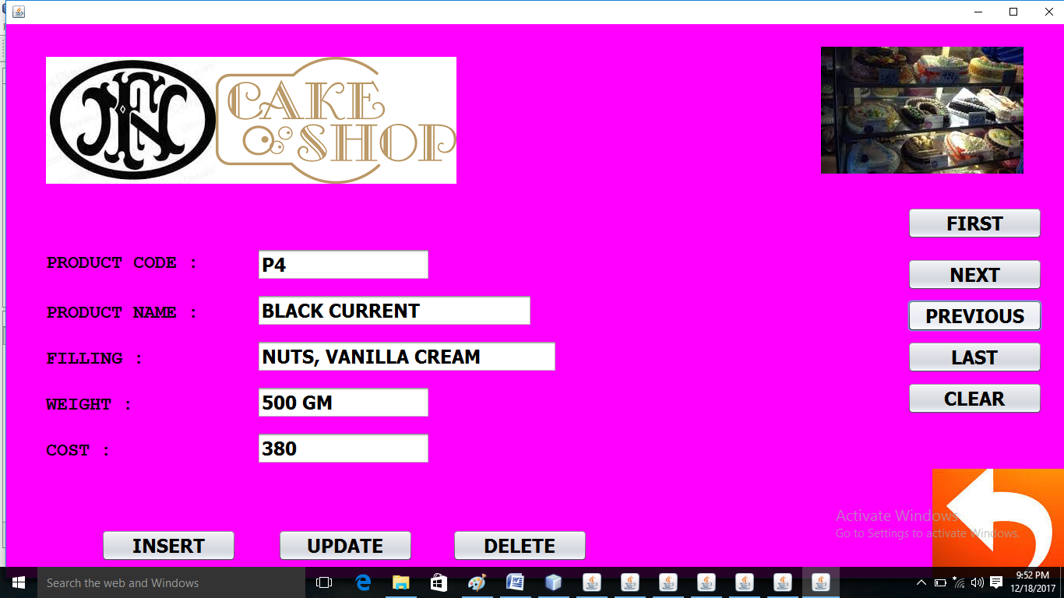

private void jButton5ActionPerformed(java.awt.event.ActionEvent evt) {

try{

r1.previous();

t1.setText(r1.getString(1));t2.setText(r1.getString(2));t3.setText(r1.getString(3));t4.setText(r1.getString(4));t5.setText(r1.getString(5));

//JOptionPane.showMessageDialog(null, "RECORD INSERTED SUCCESSFULLY!");

}

catch(Exception e){System.out.println("error"+e);}

}

PRODUCT FORM (CLEAR BUTTON)

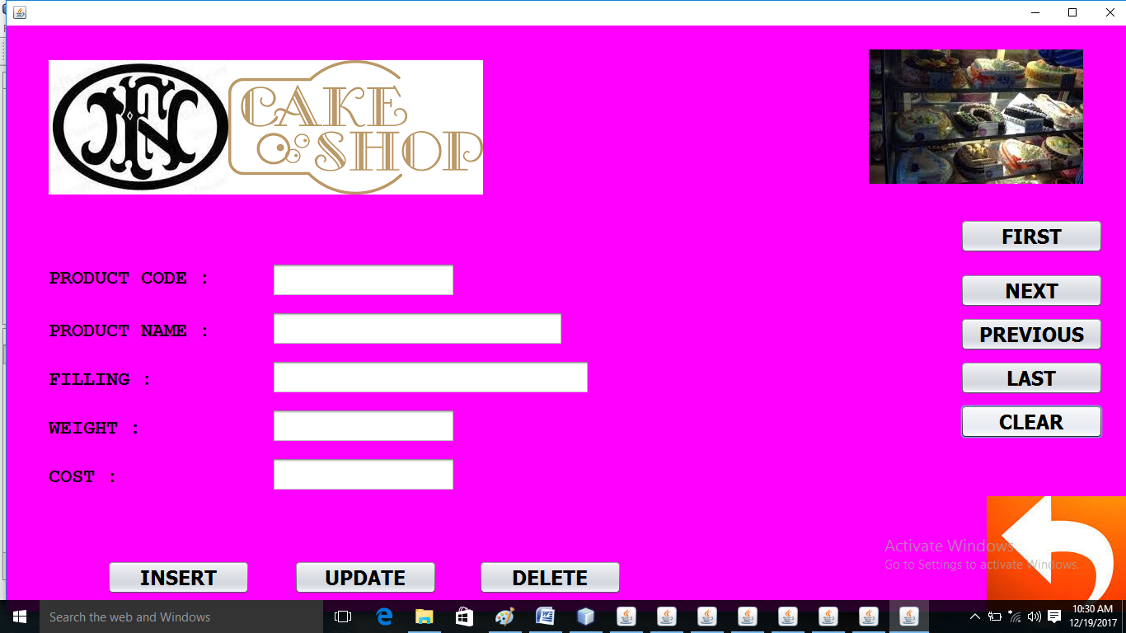

private void jButton4ActionPerformed(java.awt.event.ActionEvent evt) { t1.setText("");t2.setText("");t3.setText("");t4.setText("");t5.setText("");

}

PRODUCT FORM (INSERT RECORD)

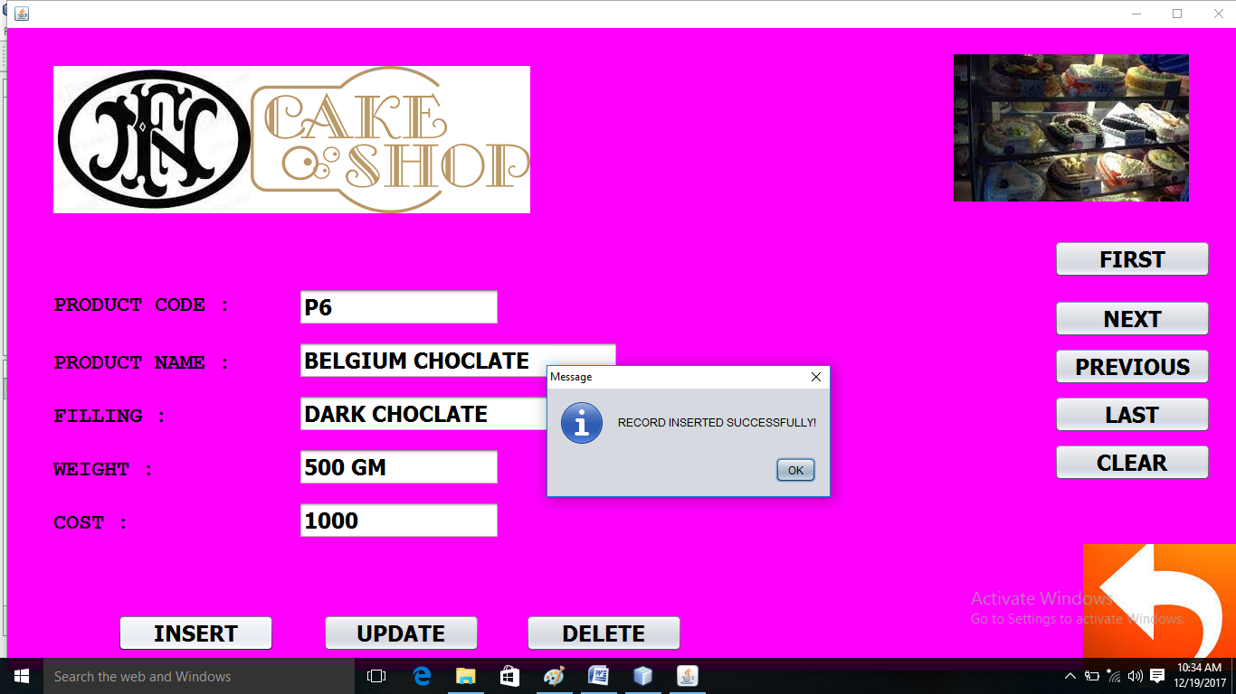

private void jButton8ActionPerformed(java.awt.event.ActionEvent evt) {

String s1=t1.getText(),s2=t2.getText(),s3=t3.getText(),s4=t4.getText();int s5=Integer.parseInt(t5.getText());

try{

Class.forName("java.sql.Driver");

Connection cn=DriverManager.getConnection("jdbc:mysql://localhost:3306/cshop","root","");

Statement st=cn.createStatement();

st.executeUpdate("insert into product values('"+s1+"','"+s2+"','"+s3+"','"+s4+"',"+s5+");");

JOptionPane.showMessageDialog(null, "RECORD INSERTED SUCCESSFULLY!");

t1.setText("");t2.setText("");t3.setText("");t4.setText("");t5.setText("");

}

catch(Exception e){System.out.println("error"+e);}

}

PRODUCT FORM (UPDATE RECORD)

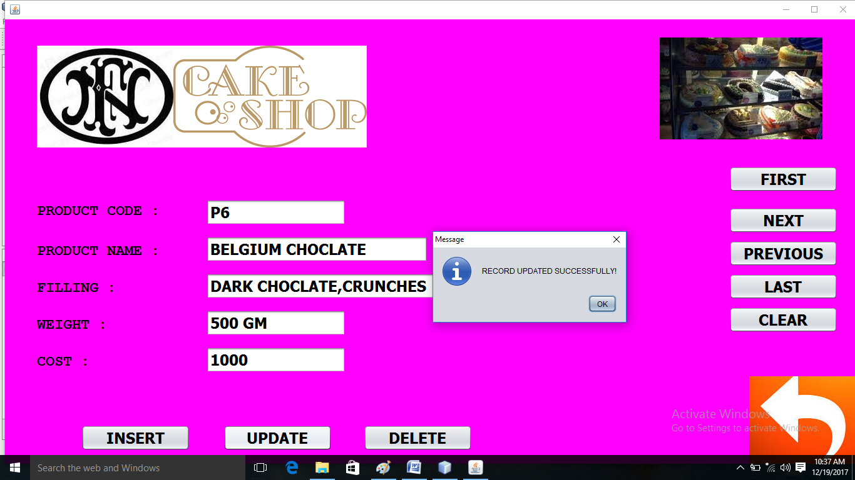

private void jButton2ActionPerformed(java.awt.event.ActionEvent evt) {

t1.setEditable(false);

String s1=t1.getText(),s2=t2.getText(),s3=t3.getText(),s4=t4.getText();int s5=Integer.parseInt(t5.getText());

try{

Class.forName("java.sql.Driver");

Connection cn=DriverManager.getConnection("jdbc:mysql://localhost:3306/cshop","root","");

Statement st=cn.createStatement();

st.executeUpdate("UPDATE product SET PNAME='"+s2+"',FIL='"+s3+"',WEIGHT='"+s4+"',COST="+s5+" WHERE PID='"+s1+"';");

JOptionPane.showMessageDialog(null, "RECORD UPDATED SUCCESSFULLY!");

t1.setText("");t2.setText("");t3.setText("");t4.setText("");t5.setText("");

}

catch(Exception e){System.out.println("error"+e);}

}

PRODUCT FORM (DELETE RECORD)

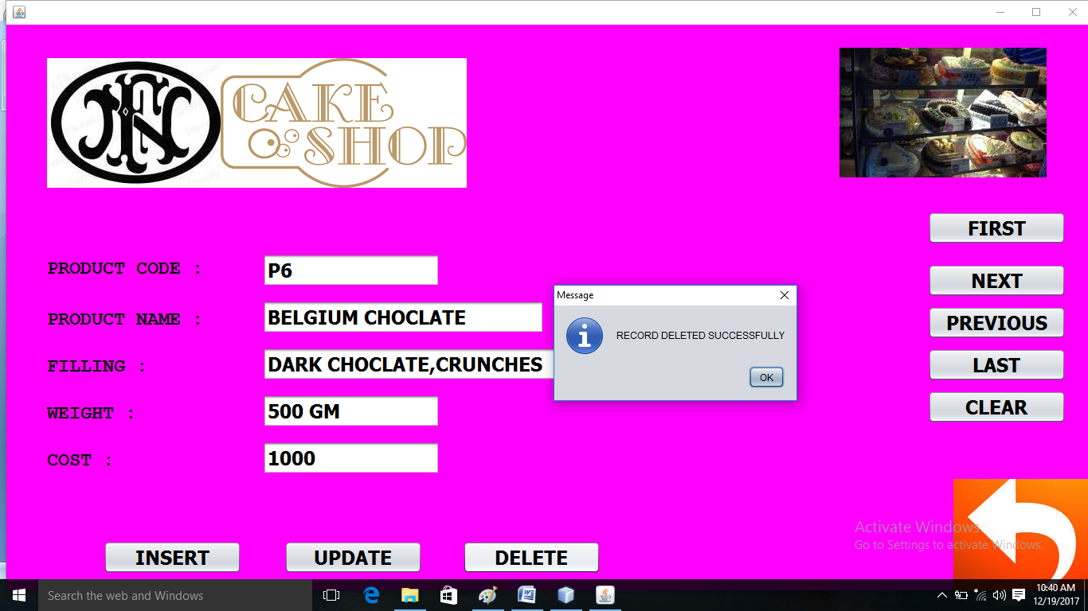

private void jButton6ActionPerformed(java.awt.event.ActionEvent evt) {

try{

Class.forName("java.sql.Driver");

Connection cn=DriverManager.getConnection("jdbc:mysql://localhost:3306/cshop","root","");

Statement st=cn.createStatement();

st.executeUpdate("DELETE FROM PRODUCT WHERE PID='"+t1.getText()+"';");

JOptionPane.showMessageDialog(null, "RECORD DELETED SUCCESSFULLY!");

t1.setText("");t2.setText("");t3.setText("");t4.setText("");t5.setText("");}

catch(Exception e){System.out.println("error"+e);} }

CUSTOMER FORM (WINDOW ACTIVATED EVENT)

private void formWindowActivated(java.awt.event.WindowEvent evt) {

this.setSize(1500, 750);t1.setEnabled(false);

try{

Class.forName("java.sql.Driver");

cn1=DriverManager.getConnection("jdbc:mysql://localhost:3306/cshop","root","");

st1=cn1.createStatement();

r1=st1.executeQuery("select * from cust");

//JOptionPane.showMessageDialog(null, "RECORD INSERTED SUCCESSFULLY!");

}

catch(Exception e){System.out.println("error"+e);}

}

CUSTOMER FORM (FIRST RECORD)

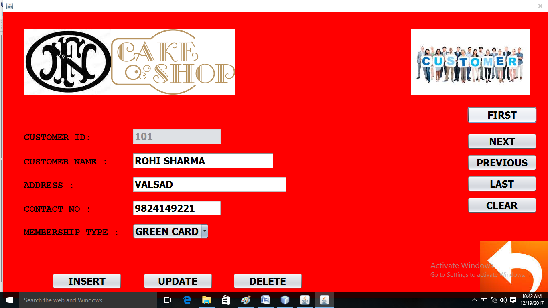

private void jButton9ActionPerformed(java.awt.event.ActionEvent evt) {

try{

r1.first();

t1.setText(r1.getString(1));t2.setText(r1.getString(2));t3.setText(r1.getString(3));t4.setText(r1.getString(4));

String s=(r1.getString(5));int i=0;

if(s.equals("NO"))i=0;

else if(s.equals("GREEN CARD"))i=1;

else if(s.equals("BLUE CARD"))i=2;

c1.setSelectedIndex(i);

}

catch(Exception e){System.out.println("error"+e);}

}

CUSTOMER FORM (NEXT RECORD)

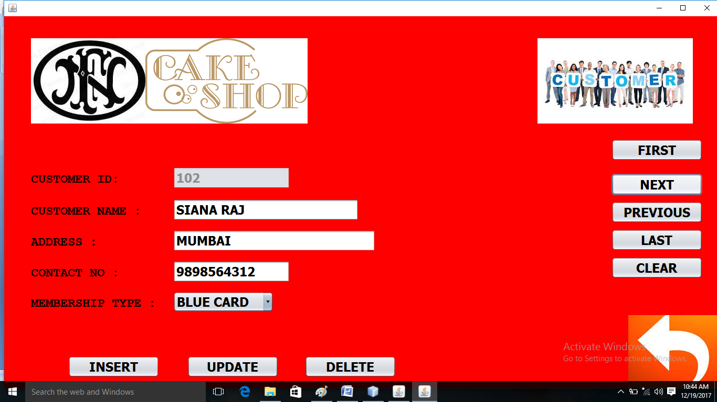

private void jButton7ActionPerformed(java.awt.event.ActionEvent evt) {

try{

r1.next();

t1.setText(r1.getString(1));t2.setText(r1.getString(2));t3.setText(r1.getString(3));t4.setText(r1.getString(4));

String s=(r1.getString(5));int i=0;

if(s.equals("NO"))i=0;

else if(s.equals("GREEN CARD"))i=1;

else if(s.equals("BLUE CARD"))i=2;

c1.setSelectedIndex(i);

//JOptionPane.showMessageDialog(null, "RECORD INSERTED SUCCESSFULLY!");

}

catch(Exception e){System.out.println("error"+e);}

}

CUSTOMER FORM (PREVIOUS RECORD)

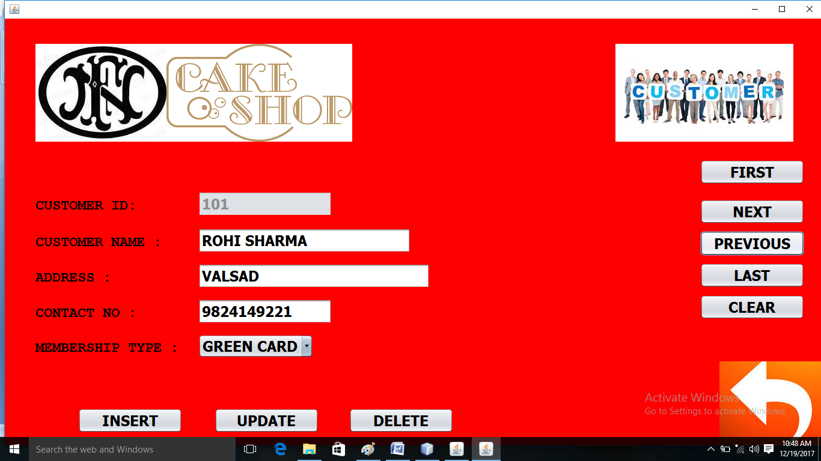

private void jButton5ActionPerformed(java.awt.event.ActionEvent evt) {

try{

r1.previous();

t1.setText(r1.getString(1));t2.setText(r1.getString(2));t3.setText(r1.getString(3));t4.setText(r1.getString(4));

String s=(r1.getString(5));int i=0;

if(s.equals("NO"))i=0;

else if(s.equals("GREEN CARD"))i=1;

else if(s.equals("BLUE CARD"))i=2;

c1.setSelectedIndex(i);

//JOptionPane.showMessageDialog(null, "RECORD INSERTED SUCCESSFULLY!");

}

catch(Exception e){System.out.println("error"+e);}

}

CUSTOMER FORM (LAST RECORD)

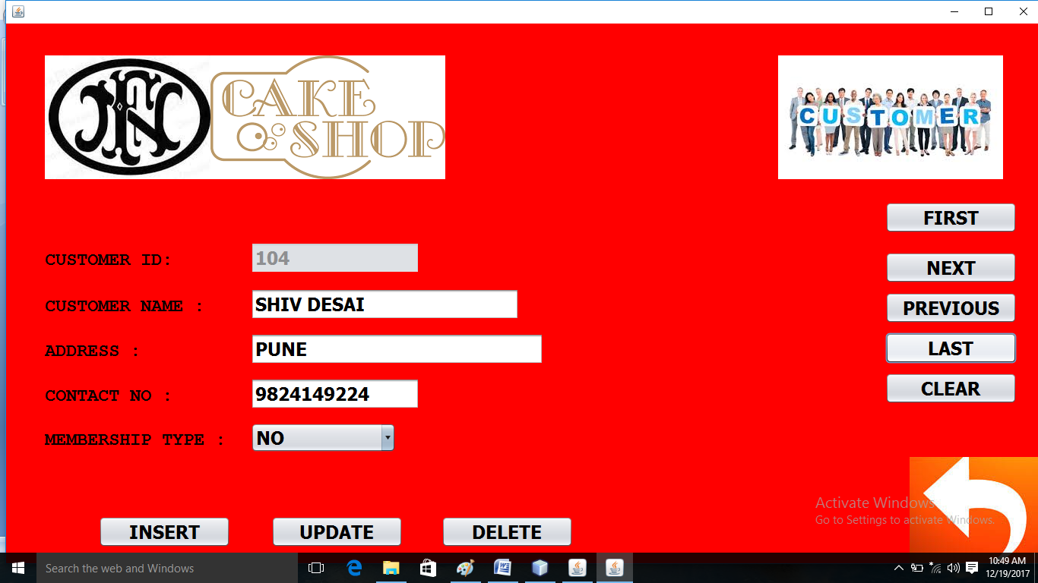

private void jButton10ActionPerformed(java.awt.event.ActionEvent evt) {

try{

r1.last();

t1.setText(r1.getString(1));t2.setText(r1.getString(2));t3.setText(r1.getString(3));t4.setText(r1.getString(4));

String s=(r1.getString(5));int i=0;

if(s.equals("NO"))i=0;

else if(s.equals("GREEN CARD"))i=1;

else if(s.equals("BLUE CARD"))i=2;

c1.setSelectedIndex(i);

//JOptionPane.showMessageDialog(null, "RECORD INSERTED SUCCESSFULLY!");

}

catch(Exception e){System.out.println("error"+e);}

}

CUSTOMER FORM (CLEAR BUTTON)

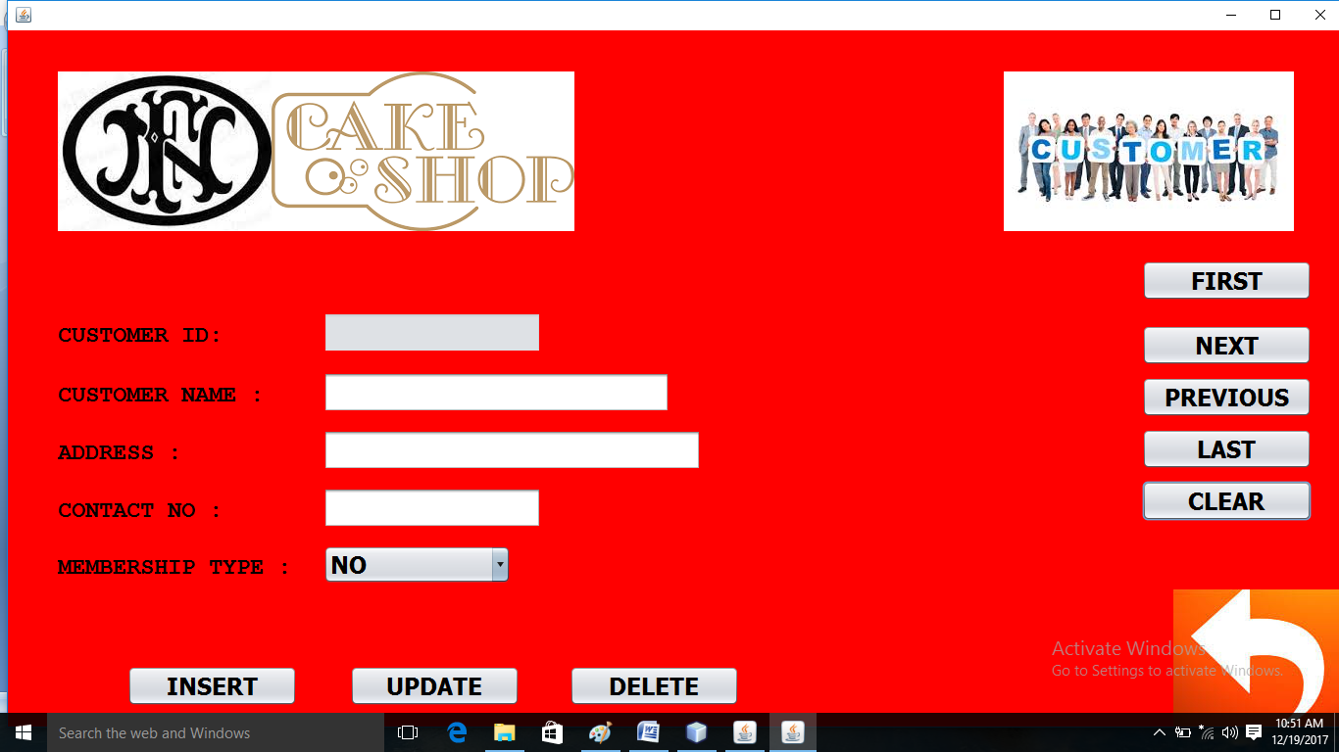

private void jButton4ActionPerformed(java.awt.event.ActionEvent evt) { t1.setText("");t2.setText("");t3.setText("");t4.setText("");c1.setSelectedIndex(0);

}

CUSTOMER FORM (INSERT RECORD)

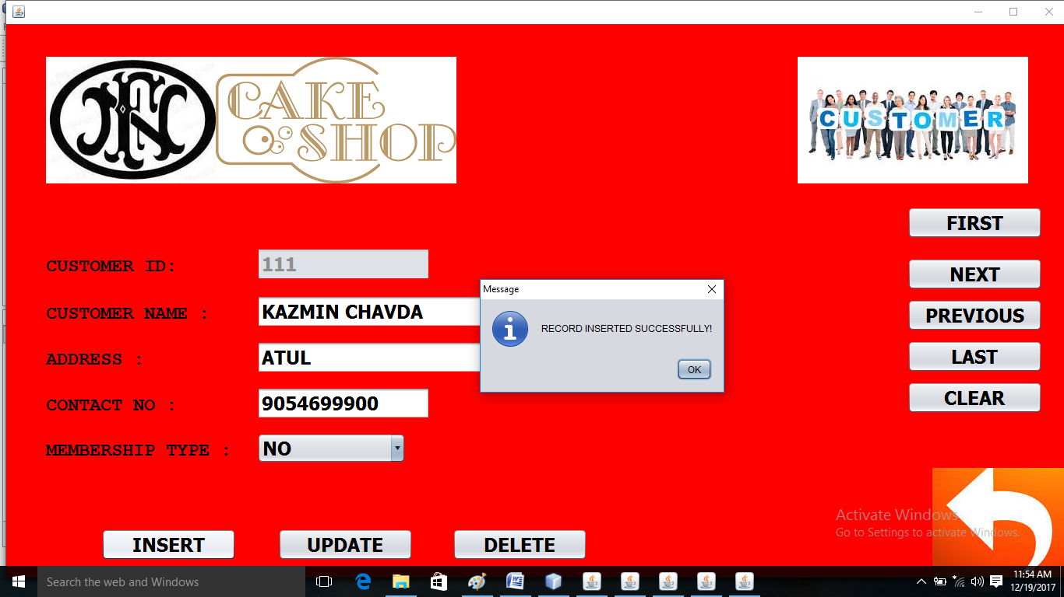

private void jButton8ActionPerformed(java.awt.event.ActionEvent evt) {

String s1=t1.getText(),s2=t2.getText(),s3=t3.getText(),s4=t4.getText(),s5=c1.getSelectedItem().toString();

try{

Class.forName("java.sql.Driver");

Connection cn=DriverManager.getConnection("jdbc:mysql://localhost:3306/cshop","root","");

Statement st=cn.createStatement();//t1.setEnabled(false);

st.executeUpdate("insert into cust(cname,cadd,contact,mship) values('"+s2+"','"+s3+"','"+s4+"','"+s5+"');");

JOptionPane.showMessageDialog(null, "RECORD INSERTED SUCCESSFULLY!");

t1.setText("");t2.setText("");t3.setText("");t4.setText("");c1.setSelectedIndex(0);

}

catch(Exception e){System.out.println("error"+e);}

}

CUSTOMER FORM (UPDATE RECORD)

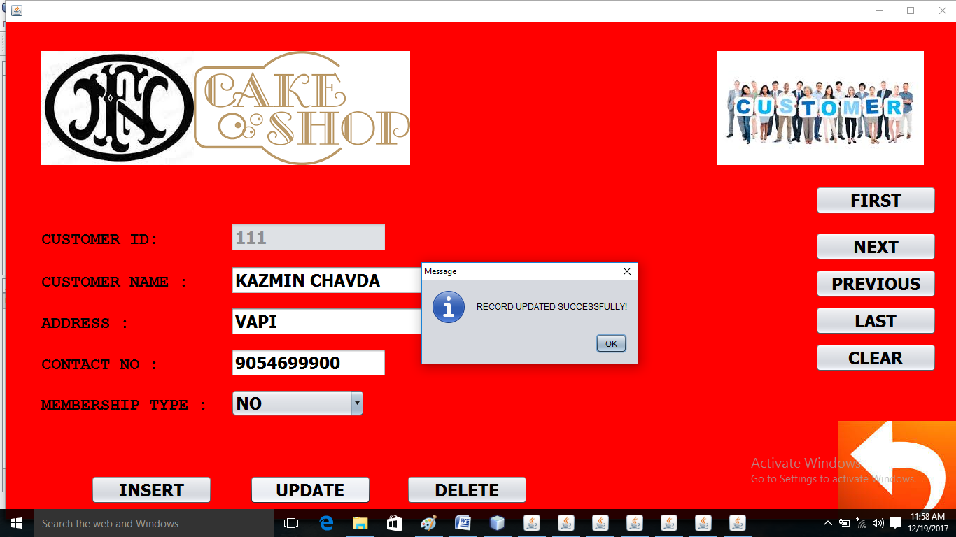

private void jButton2ActionPerformed(java.awt.event.ActionEvent evt) {

t1.setEditable(false);

String s1=t1.getText(),s2=t2.getText(),s3=t3.getText(),s4=t4.getText(), s5=c1.getSelectedItem().toString();

try{

Class.forName("java.sql.Driver");

Connection cn=DriverManager.getConnection("jdbc:mysql://localhost:3306/cshop","root","");

Statement st=cn.createStatement();

st.executeUpdate("UPDATE cust SET cNAME='"+s2+"',cadd='"+s3+"',contact='"+s4+"',mship='"+s5+"' WHERE cID="+Integer.parseInt(s1)+";");

JOptionPane.showMessageDialog(null, "RECORD UPDATED SUCCESSFULLY!");

t1.setText("");t2.setText("");t3.setText("");t4.setText("");c1.setSelectedIndex(0);

}

catch(Exception e){System.out.println("error"+e);}

}

CUSTOMER FORM (DELETE RECORD)

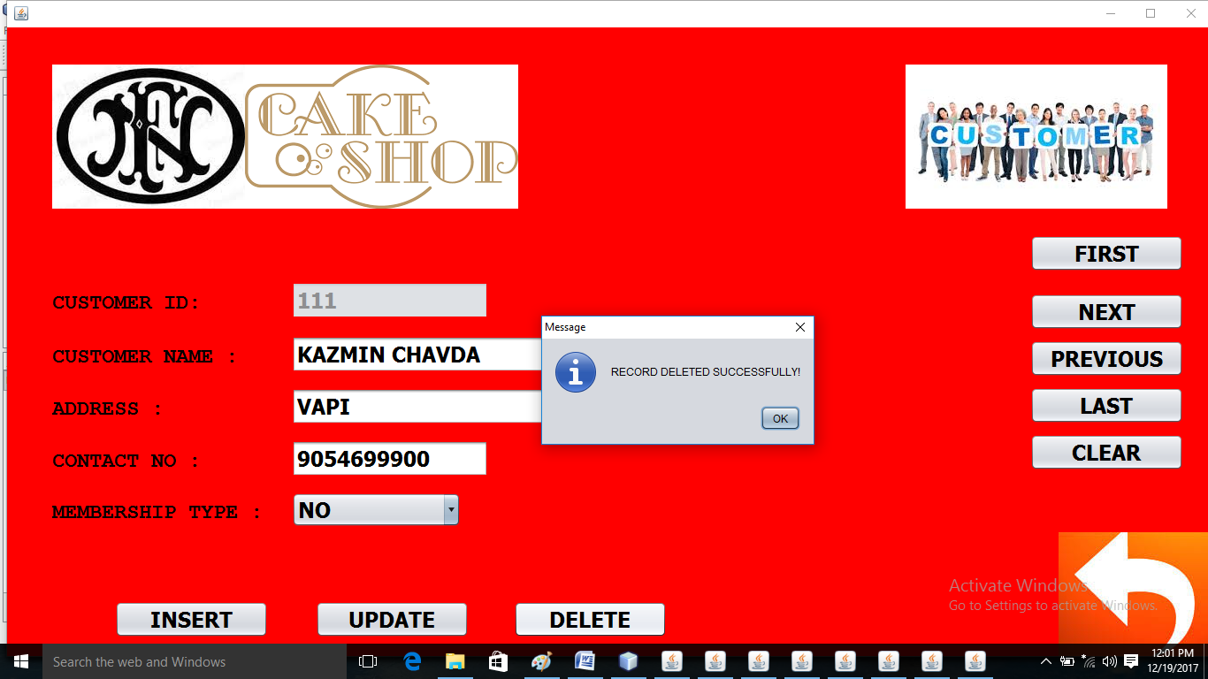

private void jButton6ActionPerformed(java.awt.event.ActionEvent evt) {

try{

Class.forName("java.sql.Driver");

Connection cn=DriverManager.getConnection("jdbc:mysql://localhost:3306/cshop","root","");

Statement st=cn.createStatement();

st.executeUpdate("DELETE FROM cust WHERE cID="+Integer.parseInt(t1.getText())+";");

JOptionPane.showMessageDialog(null, "RECORD DELETED SUCCESSFULLY!");

t1.setText("");t2.setText("");t3.setText("");t4.setText("");c1.setSelectedIndex(0);

}

catch(Exception e){System.out.println("error"+e);}

}

BILLING FORM (WINDOW ACTIVATED EVENT)

private void formWindowActivated(java.awt.event.WindowEvent evt) {

this.setSize(1500, 750);

try{

Class.forName("java.sql.Driver");

cn1=DriverManager.getConnection("jdbc:mysql://localhost:3306/cshop","root","");

st1=cn1.createStatement();

r1=st1.executeQuery("select * from bill");

//JOptionPane.showMessageDialog(null, "RECORD INSERTED SUCCESSFULLY!");

}

catch(Exception e){System.out.println("error"+e);}

}

BILLING FORM (FIRST RECORD)

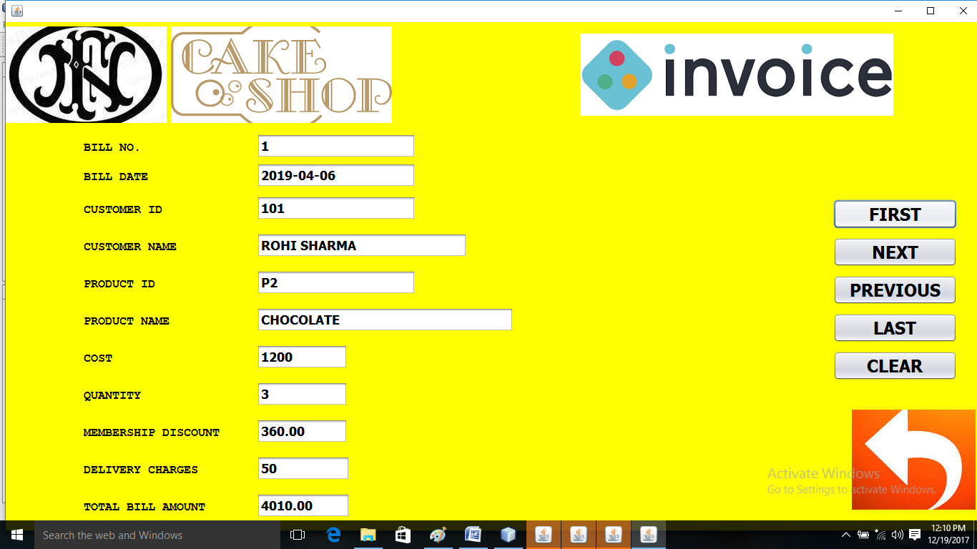

private void jButton9ActionPerformed(java.awt.event.ActionEvent evt) {

try{

r1.first();

t11.setText(r1.getString(1));t10.setText(r1.getString(2));t6.setText(r1.getString(3));t7.setText(r1.getString(4));t8.setText(r1.getString(5));t9.setText(r1.getString(6));t1.setText(r1.getString(7));t2.setText(r1.getString(8));t3.setText(r1.getString(9));t4.setText(r1.getString(10));t5.setText(r1.getString(11));

//JOptionPane.showMessageDialog(null, "RECORD INSERTED SUCCESSFULLY!"); }

catch(Exception e){System.out.println("error"+e);}

}

BILLING FORM (NEXT RECORD)

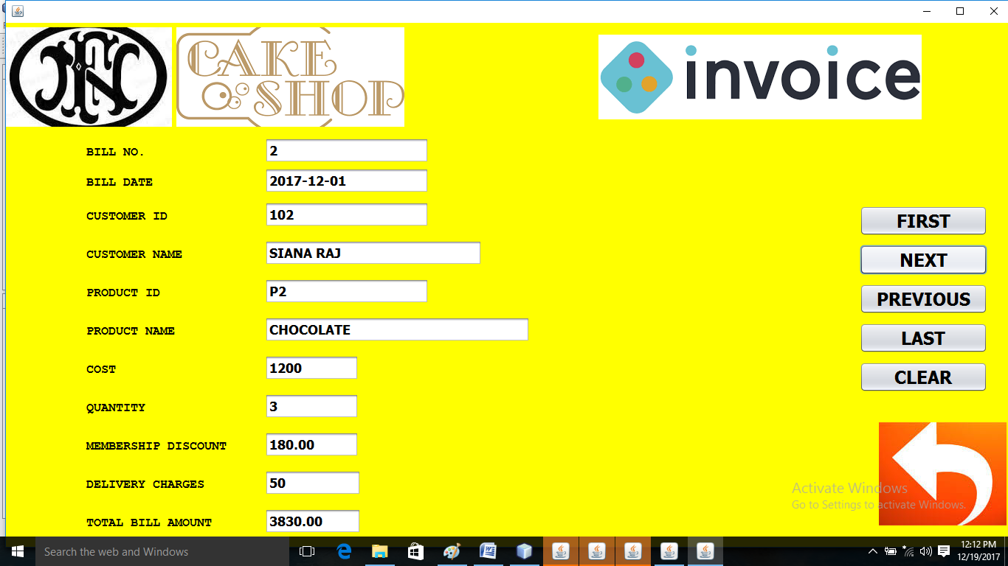

private void jButton7ActionPerformed(java.awt.event.ActionEvent evt) {

try{

if(r1.next())

t11.setText(r1.getString(1));t10.setText(r1.getString(2));t6.setText(r1.getString(3));t7.setText(r1.getString(4));t8.setText(r1.getString(5));t9.setText(r1.getString(6));t1.setText(r1.getString(7));t2.setText(r1.getString(8));t3.setText(r1.getString(9));t4.setText(r1.getString(10));t5.setText(r1.getString(11));

//JOptionPane.showMessageDialog(null, "RECORD INSERTED SUCCESSFULLY!"); }

catch(Exception e){System.out.println("error"+e);}

}

BILLING FORM (PREVIOUS RECORD)

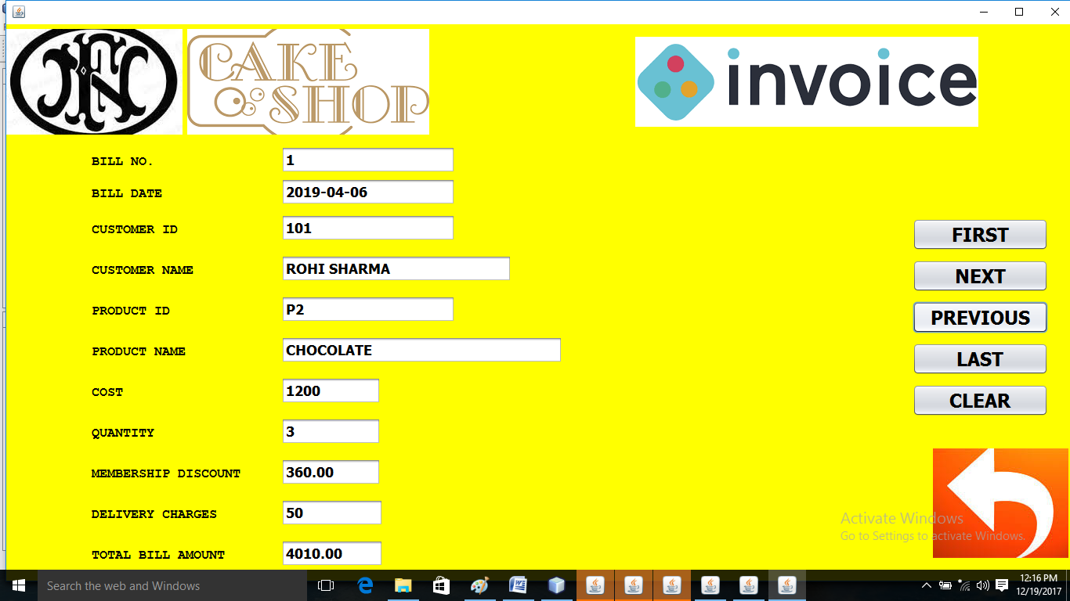

private void jButton5ActionPerformed(java.awt.event.ActionEvent evt) {

try{

if(r1.previous())

t11.setText(r1.getString(1));t10.setText(r1.getString(2));t6.setText(r1.getString(3));t7.setText(r1.getString(4));t8.setText(r1.getString(5));t9.setText(r1.getString(6));t1.setText(r1.getString(7));t2.setText(r1.getString(8));t3.setText(r1.getString(9));t4.setText(r1.getString(10));t5.setText(r1.getString(11));

//JOptionPane.showMessageDialog(null, "RECORD INSERTED SUCCESSFULLY!"); }

catch(Exception e){System.out.println("error"+e);}

}

BILLING FORM (LAST RECORD)

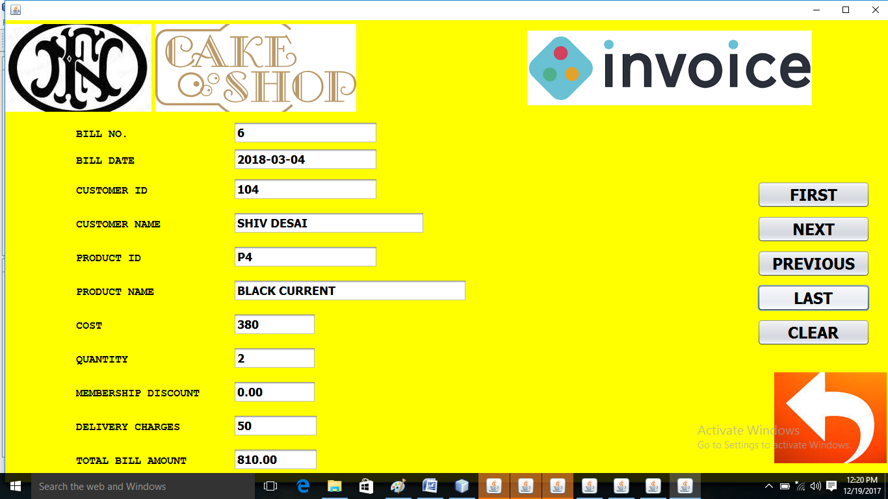

private void jButton10ActionPerformed(java.awt.event.ActionEvent evt) {

r1.last();

t11.setText(r1.getString(1));t10.setText(r1.getString(2));t6.setText(r1.getString(3));t7.setText(r1.getString(4));t8.setText(r1.getString(5));t9.setText(r1.getString(6));t1.setText(r1.getString(7));t2.setText(r1.getStri

g(8));t3.setText(r1.getString(9));t4.setText(r1.getString(10));t5.setText(r1.getString(11));

//JOptionPane.showMessageDialog(null, "RECORD INSERTED SUCCESSFULLY!");

}

catch(Exception e){System.out.println("error"+e);}

}

BILLING FORM (CLEAR BUTTON)

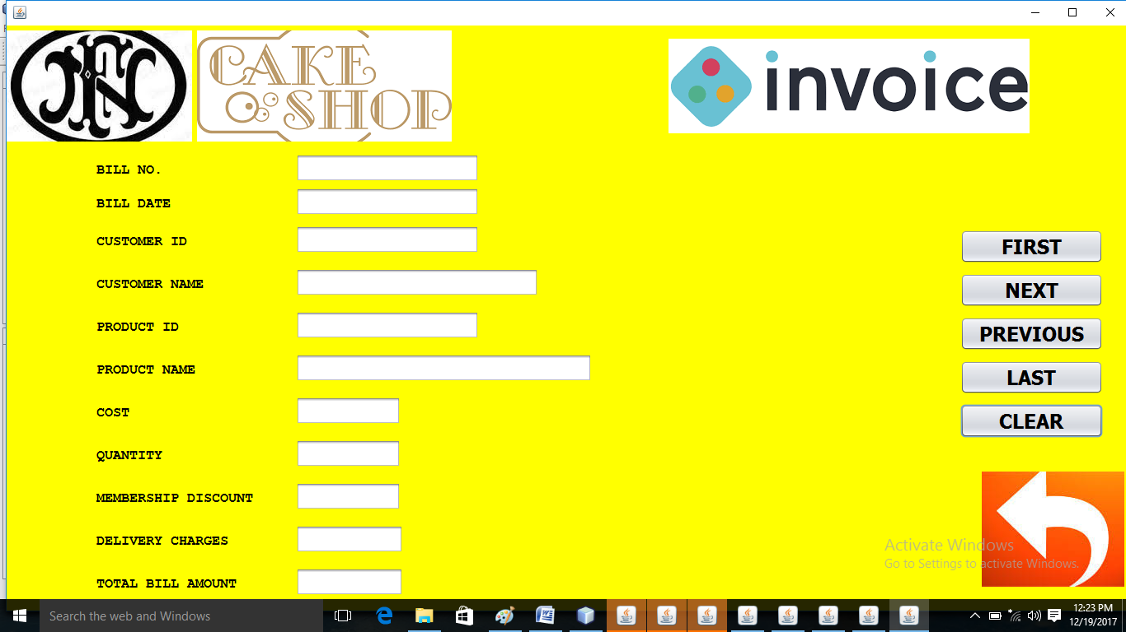

private void jButton4ActionPerformed(java.awt.event.ActionEvent evt) {

t1.setText("");t2.setText("");t3.setText("");t4.setText("");t5.setText("");t6.setText("");t7.setText("");t8.setText("");t9.setText("");t10.setText("");t11.setText(""); }

ORDER FORM (BEFORE SELECTING CUSTOMER ID AND PRODUCT ID)

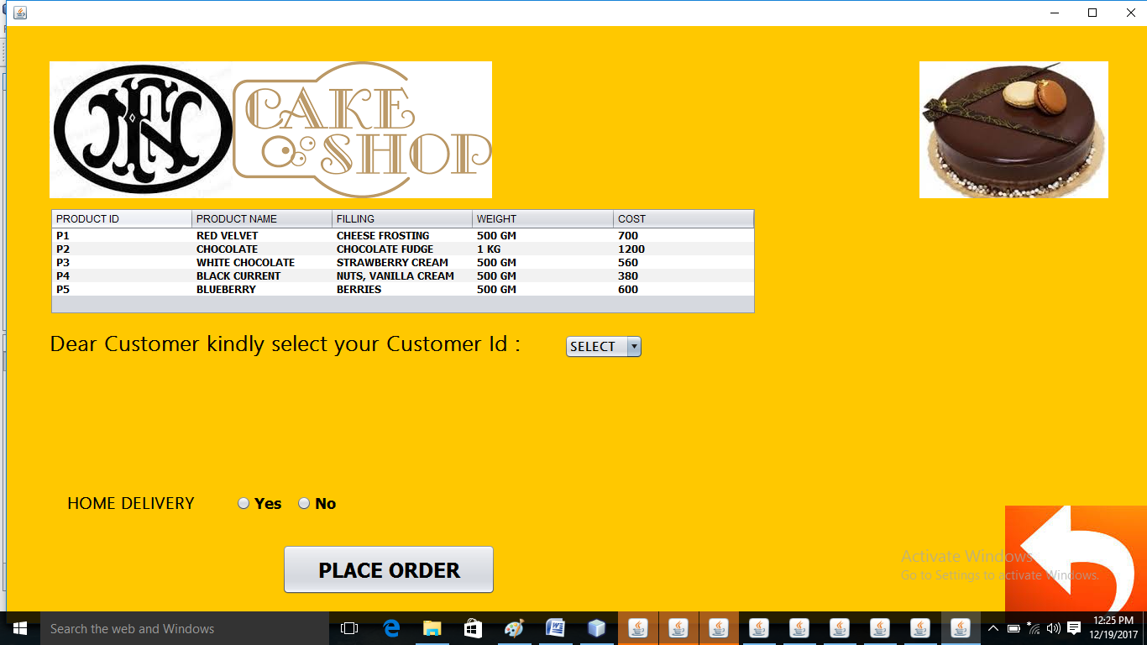

private void formWindowActivated(java.awt.event.WindowEvent evt) {

this.setSize(1500, 750);

DefaultTableModel ml=(DefaultTableModel)ta1.getModel();

l1.setVisible(false);l2.setVisible(false);l3.setVisible(false);l8.setVisible(false);t1.setVisible(false);l4.setVisible(false);l5.setVisible(false);c2.setVisible(false);

try{

Class.forName("java.sql.Driver");

cn1=DriverManager.getConnection("jdbc:mysql://localhost:3306/cshop","root","");

st1=cn1.createStatement();

r1=st1.executeQuery("select * from PRODUCT");

while(r1.next()){

ml.addRow(new Object[]{r1.getString(1),r1.getString(2),r1.getString(3),r1.getString(4),r1.getInt(5)});

}

//JOptionPane.showMessageDialog(null, "RECORD INSERTED SUCCESSFULLY!");

}

catch(Exception e){System.out.println("error"+e);}

try{

st2=cn1.createStatement();r2=st2.executeQuery("select * from cust");

while(r2.next()){

c1.addItem(r2.getString(1));

}

}

catch(Exception e){System.out.println("error"+e);}

try{

st3=cn1.createStatement();r3=st3.executeQuery("select * from product");

while(r3.next()){

c2.addItem(r3.getString(1));

}

}

catch(Exception e){System.out.println("error"+e);}

}

ORDER FORM (AFTER SELECTING CUSTOMER ID AND PRODUCT ID)

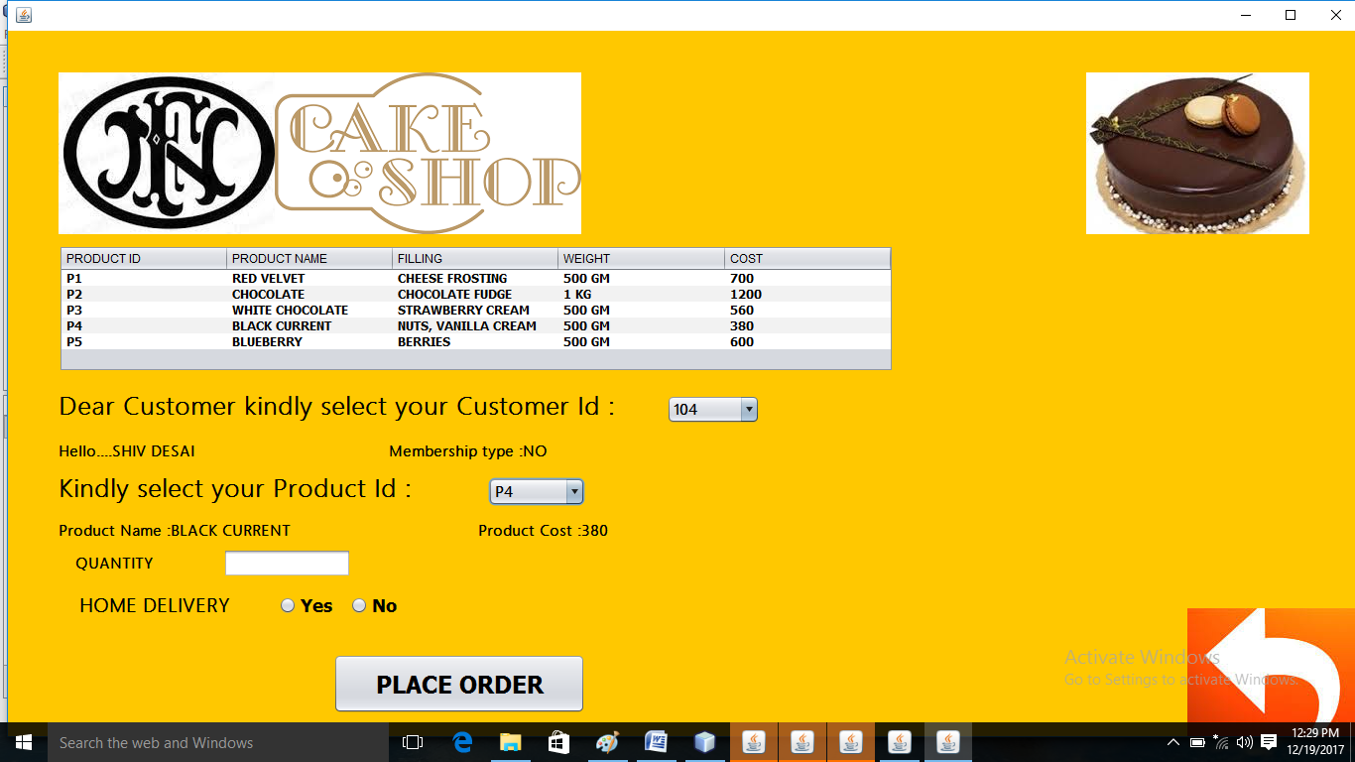

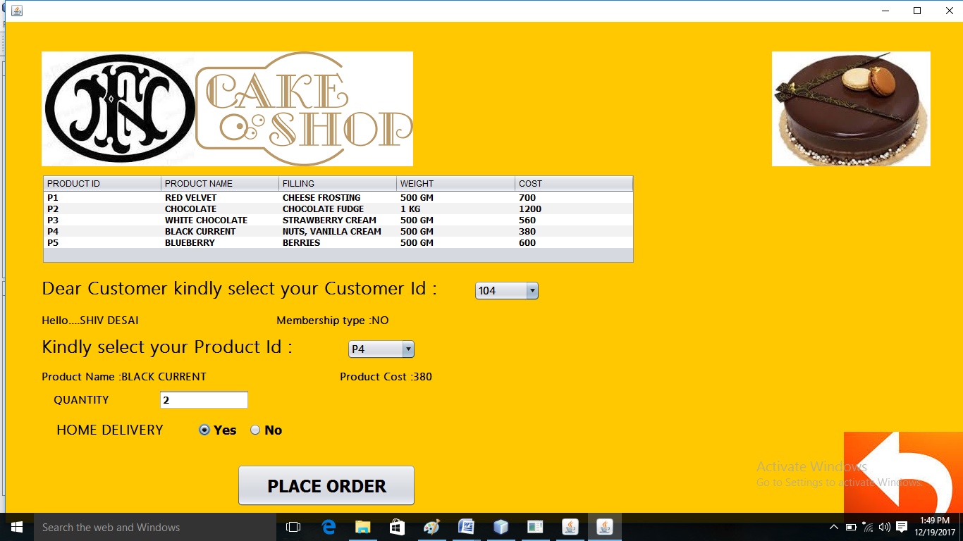

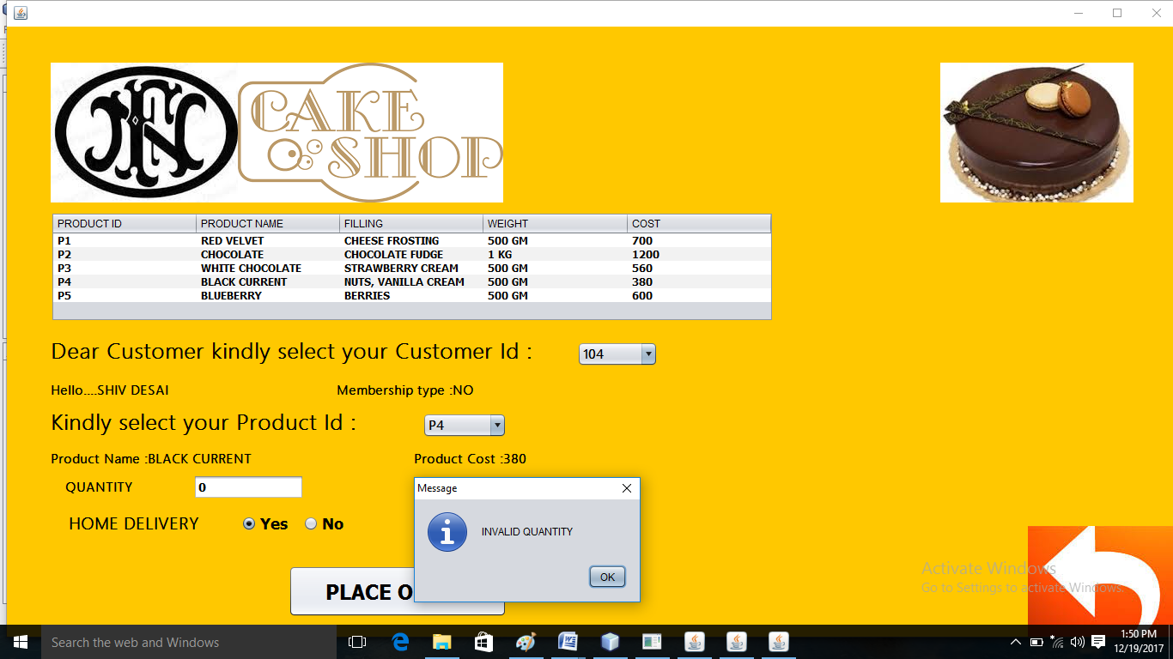

private void c1ItemStateChanged(java.awt.event.ItemEvent evt) {

ci=Integer.parseInt(c1.getSelectedItem().toString());

try{

Class.forName("java.sql.Driver");

Connection cn=DriverManager.getConnection("jdbc:mysql://localhost:3306/cshop","root","");

Statement st=cn.createStatement();//t1.setEnabled(false);

ResultSet r4=st.executeQuery("select * from cust where cid="+ci+";");

if(r4.next()){cna=r4.getString(2);mt=r4.getString(5);

l1.setText("Hello...."+cna);l2.setText("Membership type :"+mt);l1.setVisible(true);l2.setVisible(true);

l5.setVisible(true);c2.setVisible(true);}

}

catch(Exception e){System.out.println("error"+e);}

}

private void c2ItemStateChanged(java.awt.event.ItemEvent evt) {

pi= c2.getSelectedItem().toString();

try{

Class.forName("java.sql.Driver");

Connection cn=DriverManager.getConnection("jdbc:mysql://localhost:3306/cshop","root","");

Statement st=cn.createStatement();//t1.setEnabled(false);

ResultSet r4=st.executeQuery("select * from product where pid='"+pi+"';");

if(r4.next()){pn=r4.getString(2);co=Integer.parseInt(r4.getString(5));

l3.setText("Product Name :"+pn);l8.setText("Product Cost :"+co);l2.setVisible(true);

l3.setVisible(true);l8.setVisible(true);t1.setVisible(true);l4.setVisible(true);

}}

catch(Exception e){System.out.println("error"+e);}

}

private void jButton8ActionPerformed(java.awt.event.ActionEvent evt) {

if(R1.isSelected())

d="Y";

else d="N";

BILL b=new BILL();

q=Integer.parseInt(t1.getText());

if (q<=0)

{

JOptionPane.showMessageDialog(null, "INVALID QUANTITY");

}

else

{

t1.setText("");

}

b.q=q;

b.d=d;b.cna=cna;b.mt=mt;b.pi=pi;b.pn=pn;b.ci=ci;b.co=co;

this.dispose();b.setVisible(true);

}

PLACE ORDER (WINDOW ACTIVATED EVENT )

private void formWindowActivated(java.awt.event.WindowEvent evt) {

this.setSize(1500, 750);int i;

for(i=2017;i<=2050;i++) c1.addItem(""+i);

for(i=1;i<=12;i++) c3.addItem(""+i);

l10.setText(""+ci);l11.setText(cna);l12.setText(mt); l20.setText(""+pi);l22.setText(""+pn);l24.setText(""+co);l26.setText(""+q);

bill=co*q;

if(mt.equals("GREEN CARD"))mdis=bill*0.10;

else if(mt.equals("BLUE CARD"))mdis=bill*0.05;

else mdis=bill*0;

if(d.equals("Y"))del=50; else del=0;

tot=bill-mdis+del; l14.setText(""+bill);l16.setText(""+mdis);l18.setText(""+del);l27.setText("YOUR TOTAL BILL AMOUNT IS "+tot+" RS.");

}

public class BILL extends javax.swing.JFrame {

Connection cn;Statement st;ResultSet r;String d,cna,mt,pi,pn;int ci,co,q,bill=0,del=0;double mdis=0,tot=0; }

PLACE ORDER BUTTON

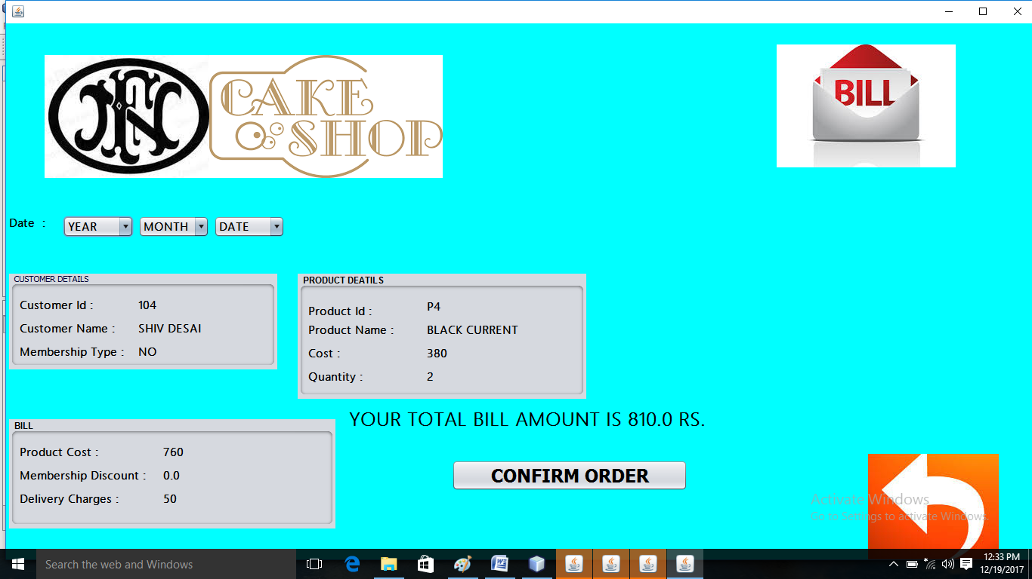

private void jButton8ActionPerformed(java.awt.event.ActionEvent evt) {

if(R1.isSelected())

d="Y";

else d="N";

BILL b=new BILL();

q=Integer.parseInt(t1.getText());

if (q<=0)

{

JOptionPane.showMessageDialog(null, "INVALID QUANTITY");

}

else

{

t1.setText("");

}

b.q=q;

b.d=d;b.cna=cna;b.mt=mt;b.pi=pi;b.pn=pn;b.ci=ci;b.co=co;

this.dispose();b.setVisible(true);

}

public class ORDER extends javax.swing.JFrame {

Connection cn1;Statement st1,st2,st3;ResultSet r1,r2,r3;String d,cna,mt,pi,pn;int q, ci,co;

MAIN BILL FORM

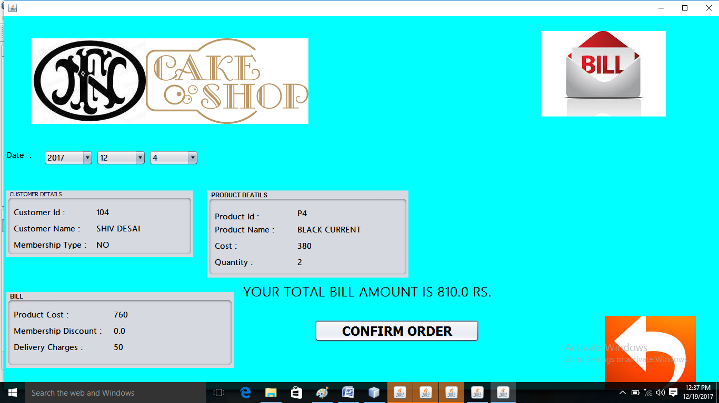

private void jButton8ActionPerformed(java.awt.event.ActionEvent evt) {

int y=Integer.parseInt(c1.getSelectedItem().toString()),m=Integer.parseInt(c3.getSelectedItem().toString()),d=Integer.parseInt(c2.getSelectedItem().toString());

String da=y+"/"+m+"/"+d;

try{

Class.forName("java.sql.Driver");

Connection cn=DriverManager.getConnection("jdbc:mysql://localhost:3306/cshop","root","");

Statement st=cn.createStatement();//t1.setEnabled(false);

st.executeUpdate("insert into bill(bdate,cid,cname,pid,pname,cost,qty,mdis,del,tot) values('"+da+"',"+ci+",'"+cna+"','"+pi+"','"+pn+"',"+co+","+q+","+mdis+","+del+","+tot+");");

}

catch(Exception e){System.out.println("error"+e);}

}

BACK BUTTON

private void jButton11ActionPerformed(java.awt.event.ActionEvent evt) {

main m=new main();

this.dispose();

m.setVisible(true);

}

**BIBLIOGRAPHY**

* **MR.ASHOK BIST SIR**
* **TEXTBOOK OF CLASS 12 (SUMIT ARORA)**
* **GOOGLE CHROME**

**REMARKS**